**UNIT 3 & 4 CHEM Name: _______________**

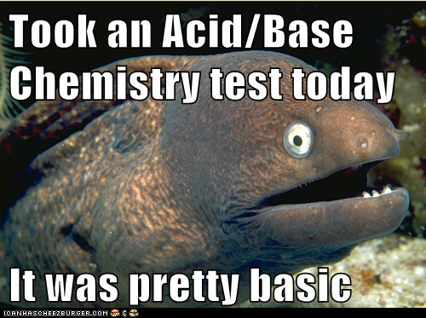

**TOPIC 2:**   
ACIDS & BASES

Syllabus dot-points

**Science as a Human Endeavour:**

**Models of acids and bases:**Models and theories are contested and refined or replaced when new evidence challenges them, or when a new model or theory has greater explanatory scope. Davy initially proposed that acids were substances that contained replaceable hydrogen (hydrogen that could be partly or totally replaced by metals) and bases were substances that reacted with acids to form salts and water. The Arrhenius model, which includes only soluble acids and bases, identified acids as substances which produce hydrogen ions in solution and bases as substances which produce hydroxide ions in solution. Subsequently, the Brønsted-Lowry model describes acid-base behaviour in terms of proton donors and proton acceptors. This approach includes a wider range of substances and can be more broadly applied.

**Ocean Acidification:**

Levels of carbon dioxide in the atmosphere are rising and have a significant impact on global systems, including surface temperatures. The increasing level of carbon dioxide in the atmosphere causes more carbon dioxide to dissolve in the ocean producing carbonic acid and leading to increased ocean acidity. This is predicted to have a range of negative consequences for marine ecosystems such as coral reefs. Calcification is the process which results in the formation of calcium carbonate structures in marine organisms. Acidification shifts the equilibrium of carbonate chemistry in seawater, decreasing the rate and amount of calcification among a wide range of marine organisms. The United Nations Kyoto Protocol and the Intergovernmental Panel on Climate Change aim to secure a global commitment to reducing greenhouse gas emissions over the next few decades.

**Science Understanding:**

* acids are substances that can act as proton (hydrogen ion) donors and can be classified as monoprotic or polyprotic, depending on the number of protons available for donation
* the relationship between acids and bases in equilibrium systems can be explained using the Brønsted-Lowry model and represented using chemical equations that illustrate the transfer of protons between conjugate acid-base pairs
* the strength of acids is explained by the degree of ionisation at equilibrium in aqueous solution which can be represented by chemical equations and acidity constants (Ka)
* acid-base indicators are weak acids, or weak bases, in which the acidic form is a different colour from the basic form
* the hydrolysis of salts of weak acids and weak bases can be represented using equations; the Brønsted-Lowry model can be applied to explain the acidic, basic and neutral nature of salts derived from bases and monoprotic and polyprotic acids
* water is a weak electrolyte; the self-ionisation of water is represented by Kw = [H+][OH-] where Kw = 1.0 x 10-14 at 25 °C
* Kw can be used to calculate the concentration of hydrogen ions or hydroxide ions in solutions of strong acids or bases
* the pH scale is a logarithmic scale and the pH of a solution can be calculated from the concentration of hydrogen ions using the relationship pH = - log10 [H+]
* buffer solutions are conjugate in nature and resist changes in pH when small amounts of strong acid or base are added to the solution; buffering capacity can be explained qualitatively; Le Châtelier’s Principle can be applied to predict how buffers respond to the addition of hydrogen ions and hydroxide ions

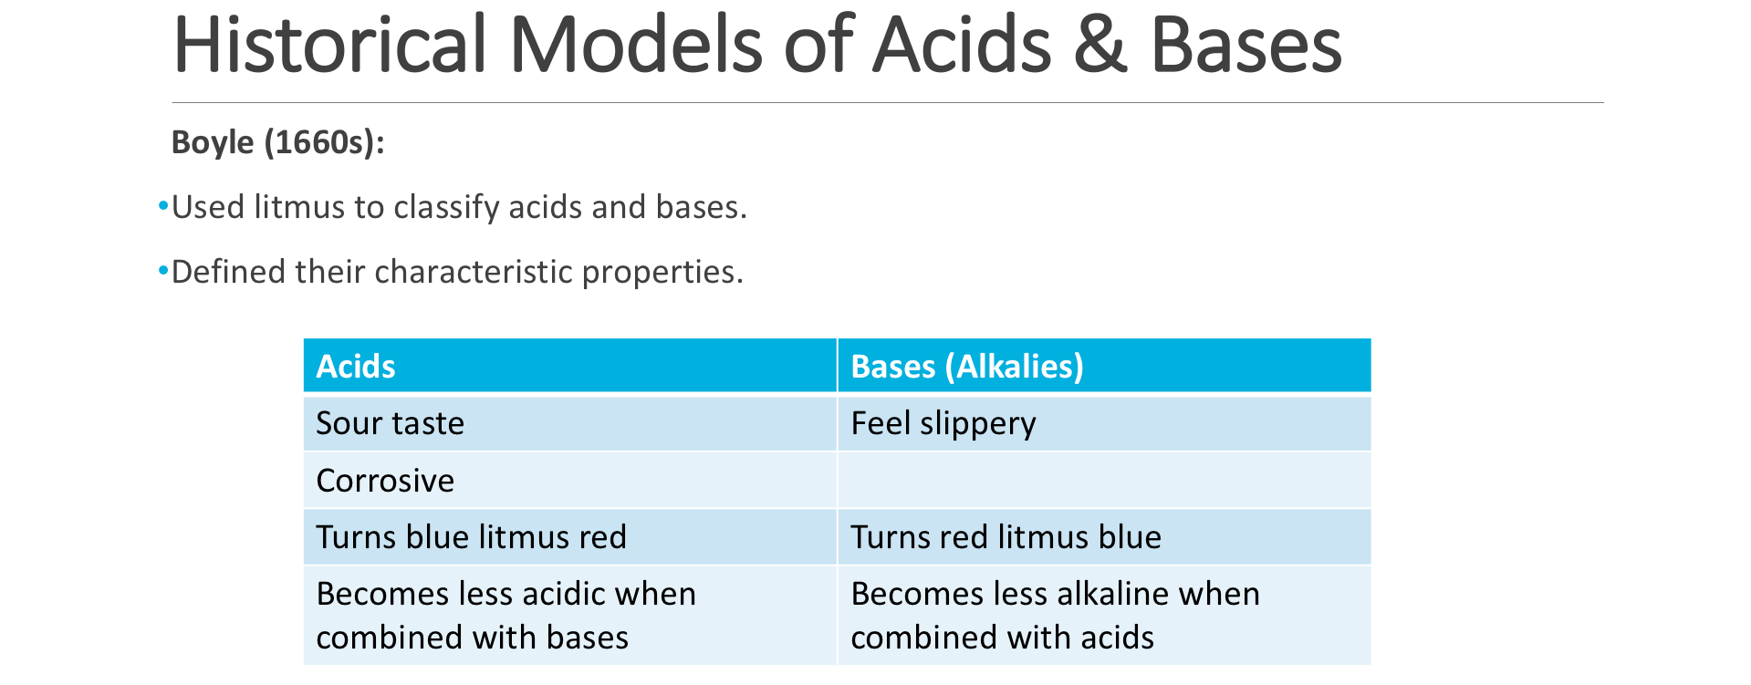

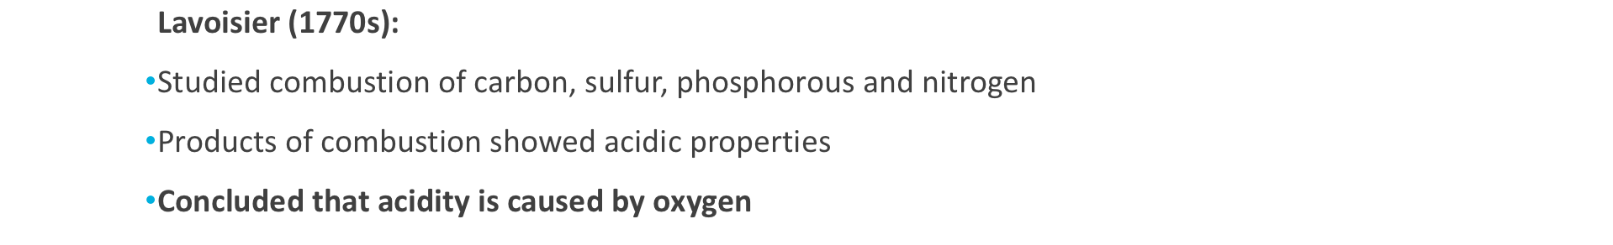

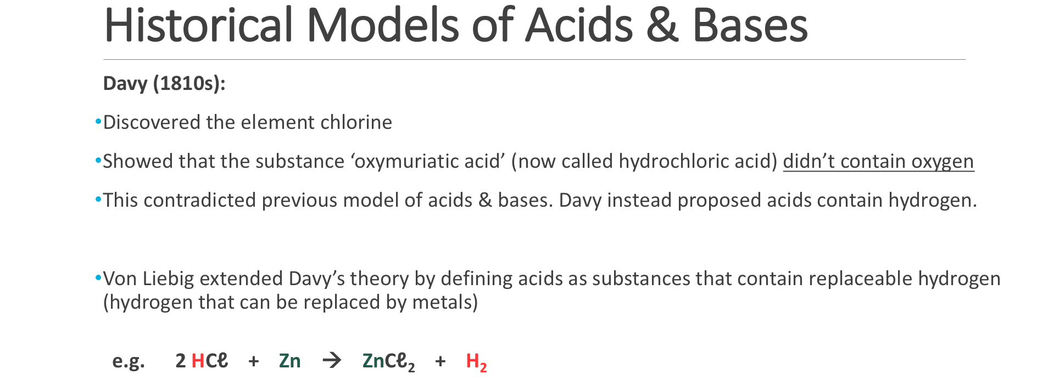

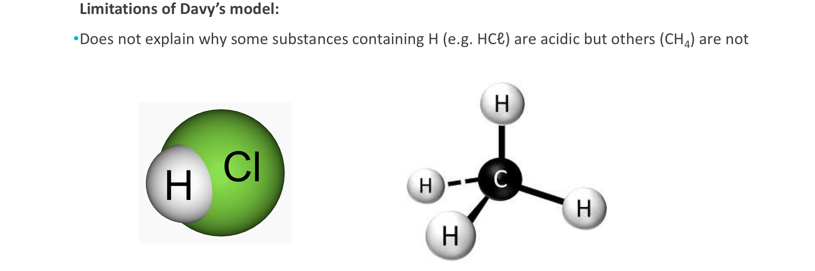

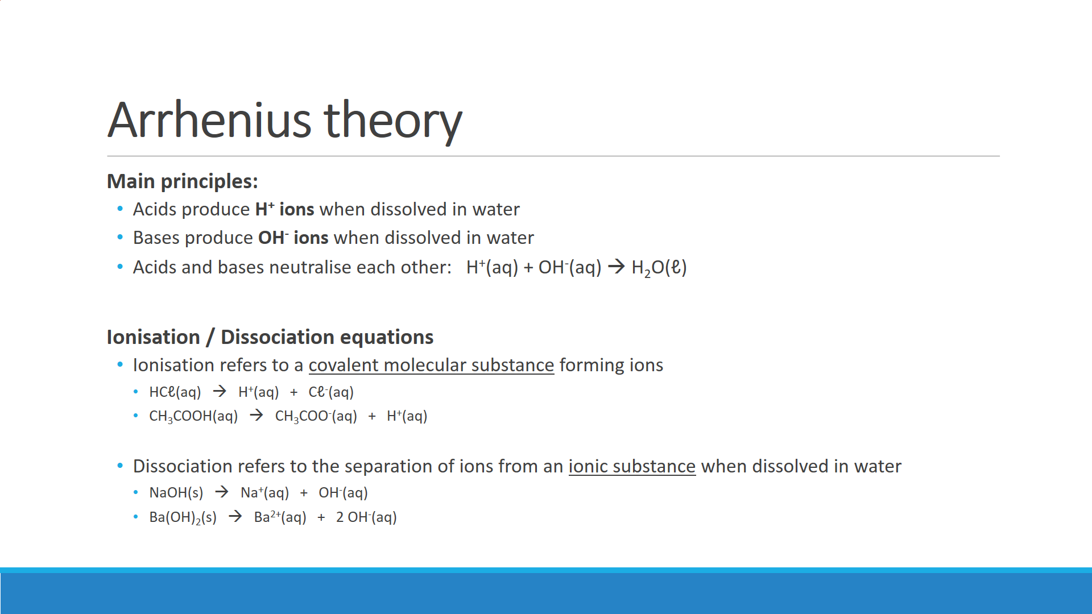

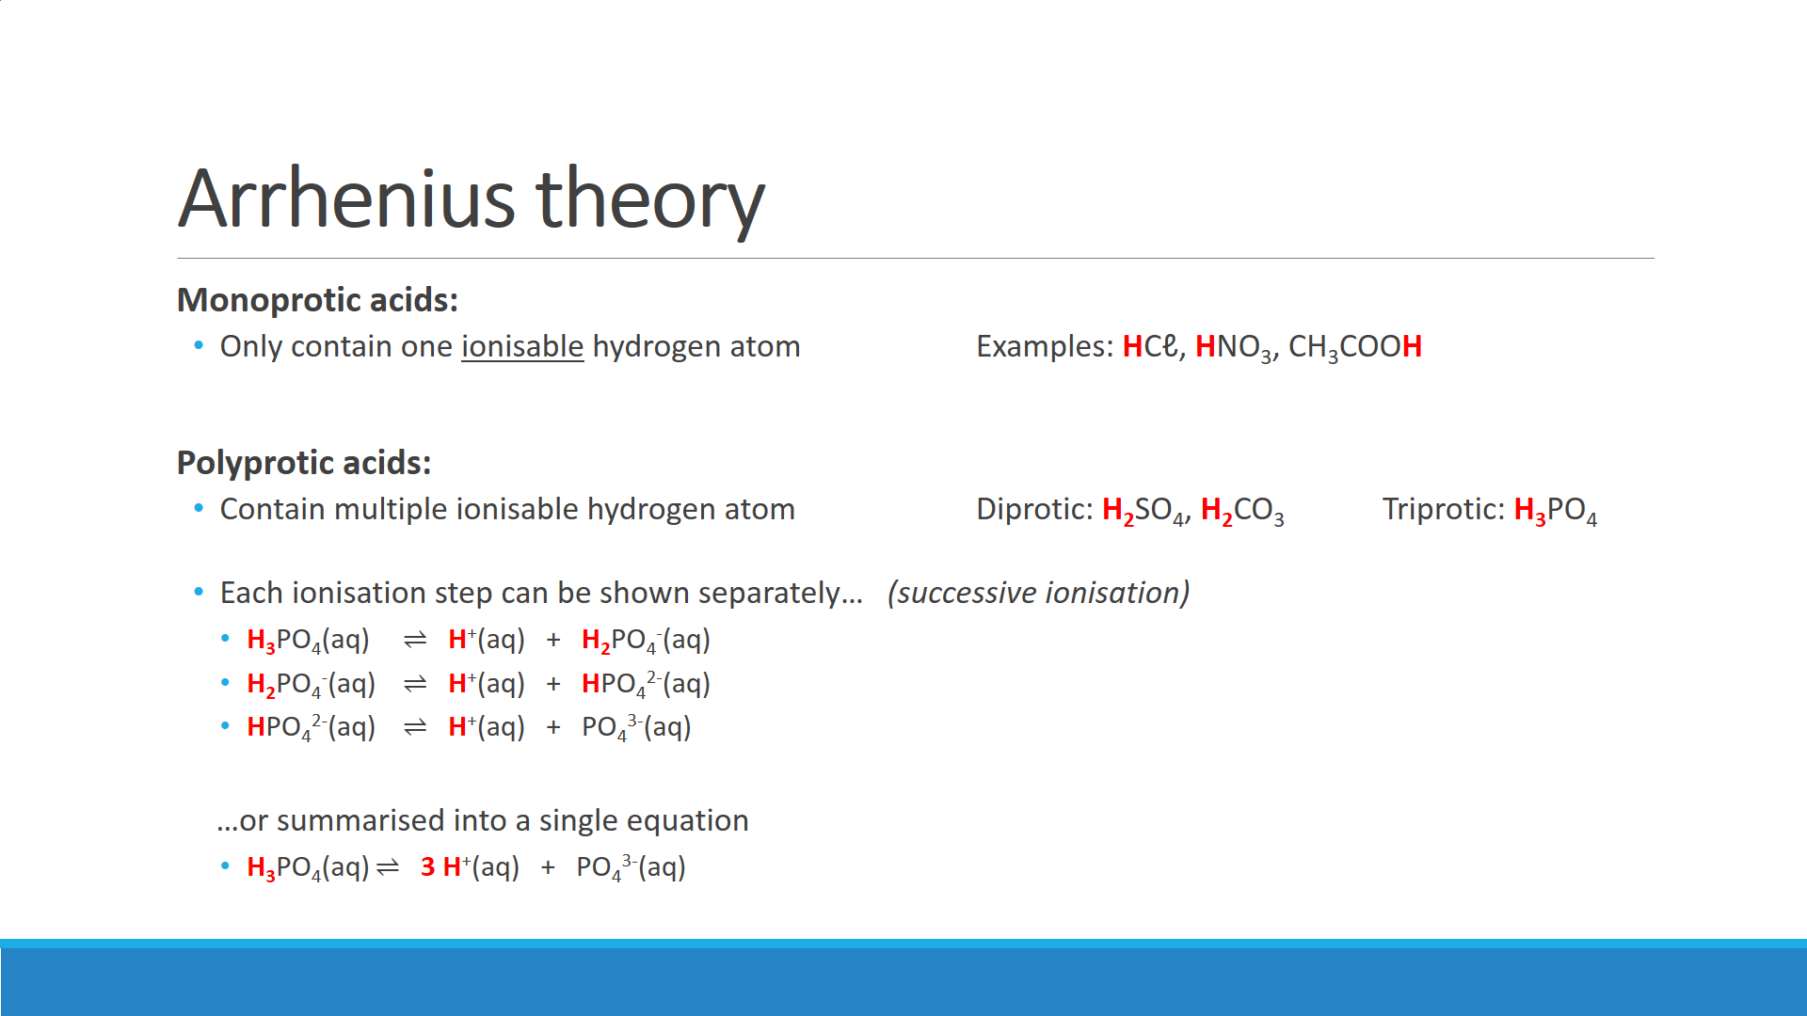

Citric acid (C6H8O7) is a weak, triprotic acid. Write successive ionisation equations for citric acid.

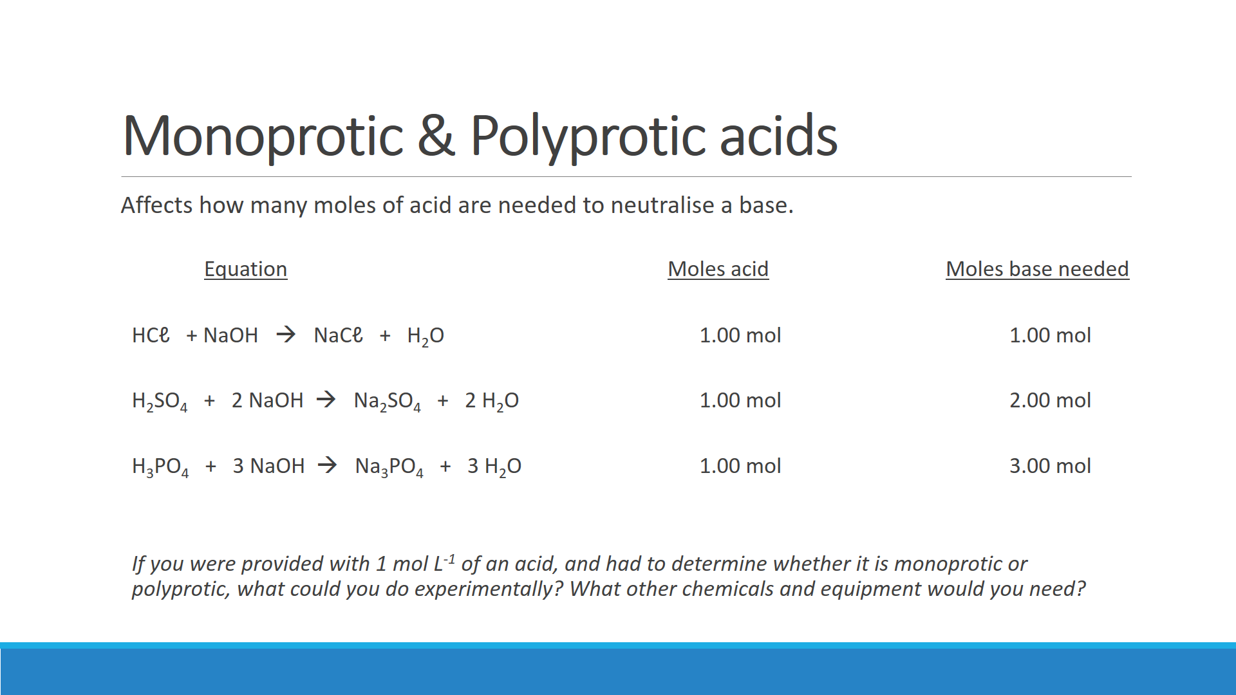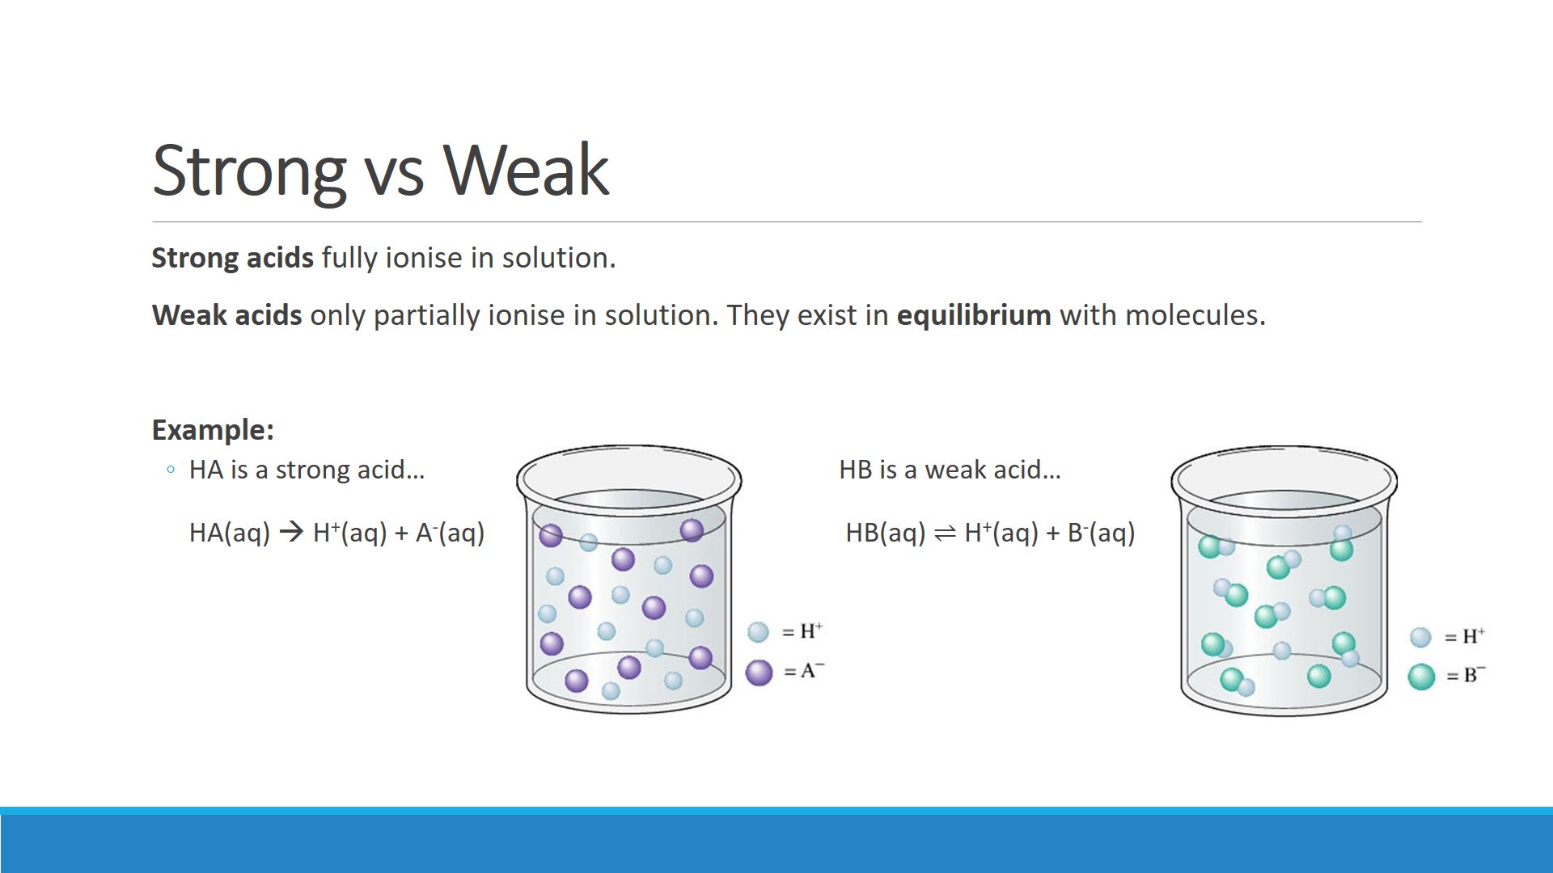

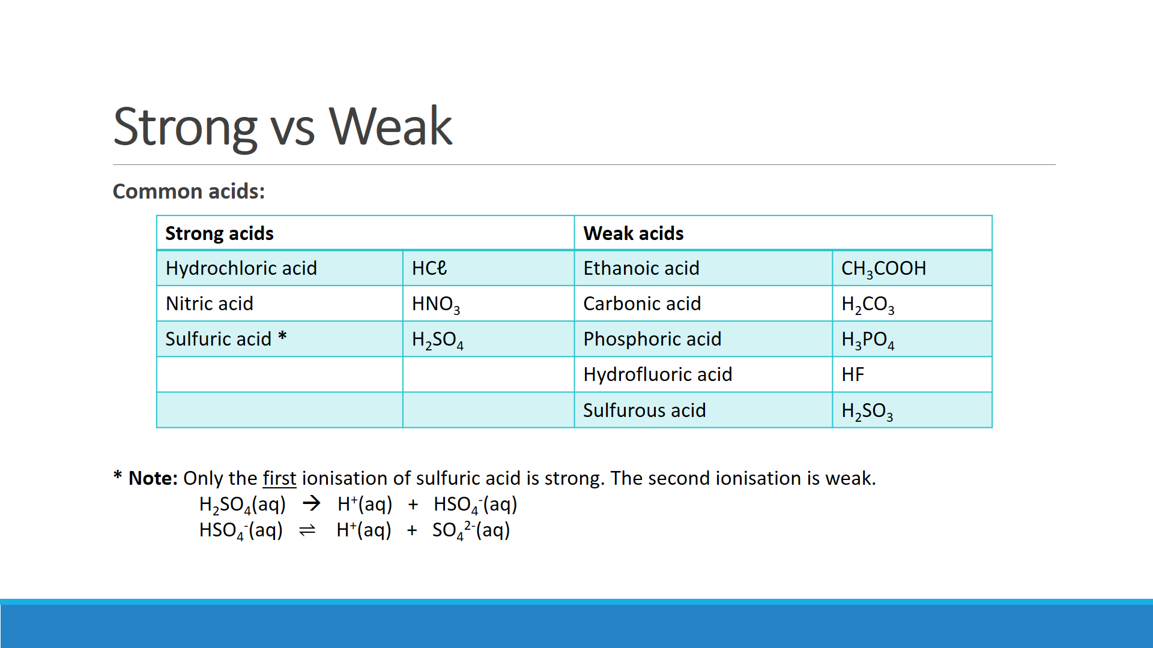

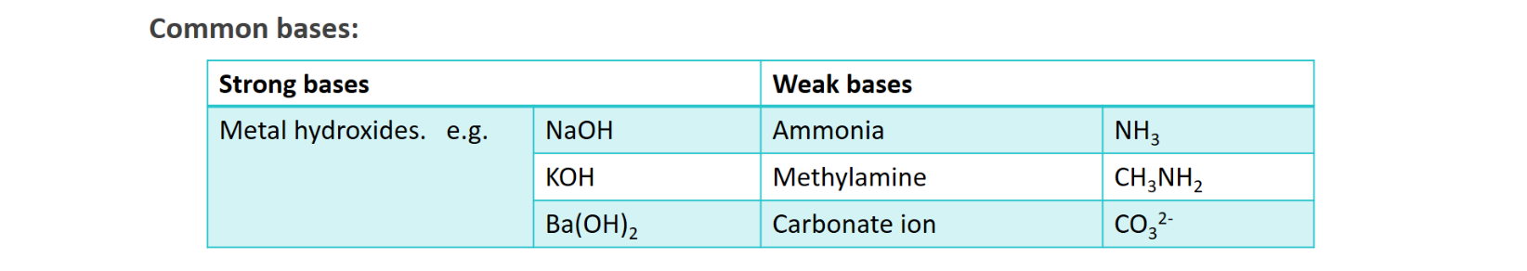

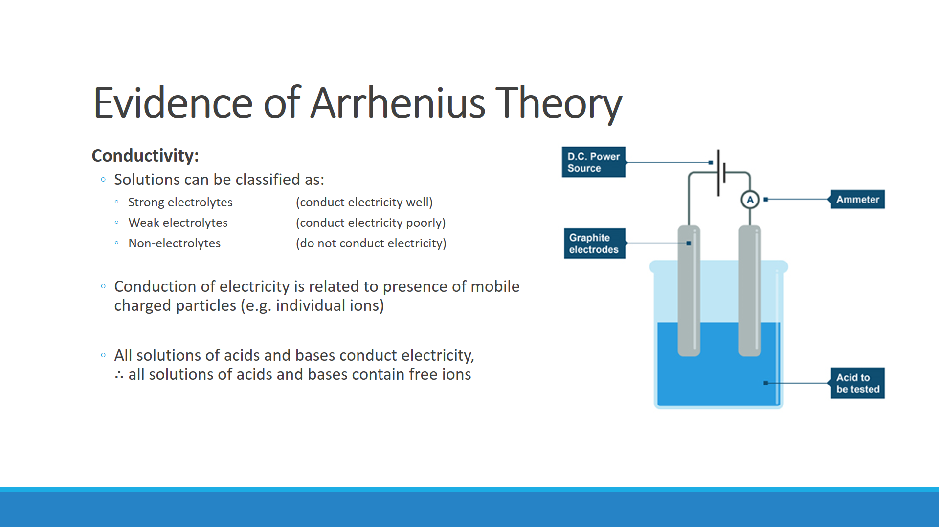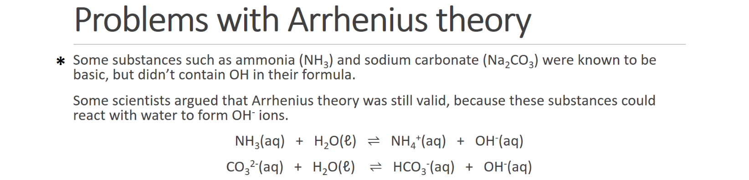

**.**



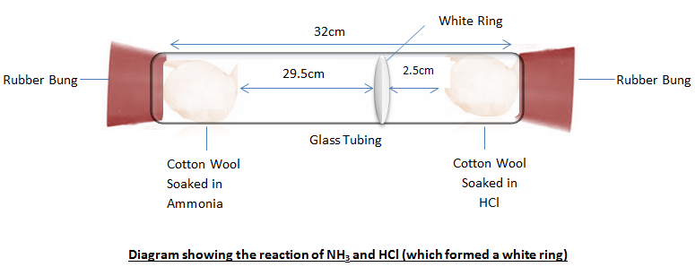

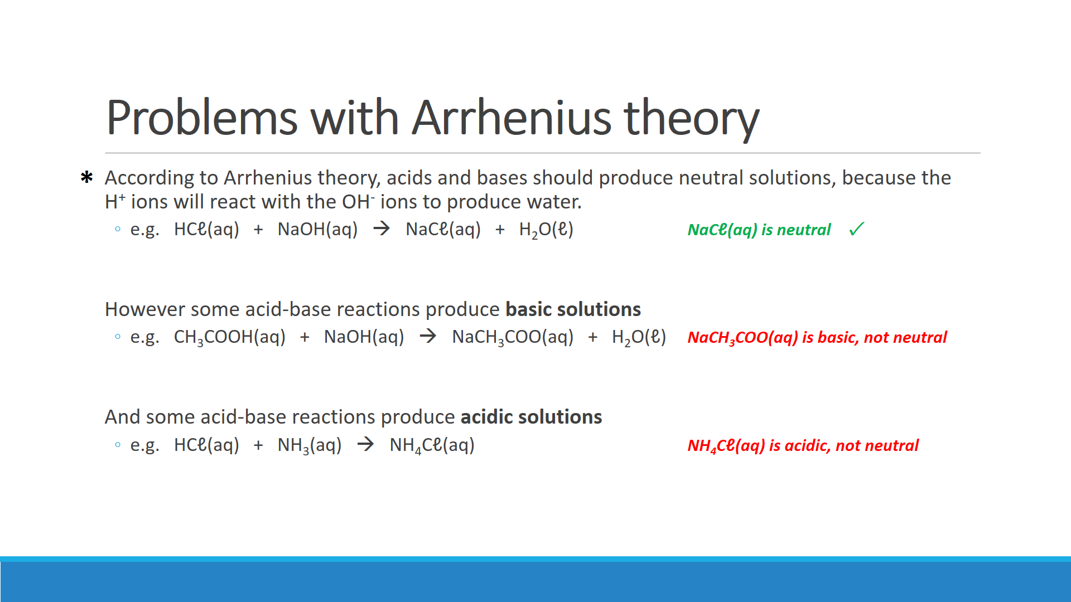

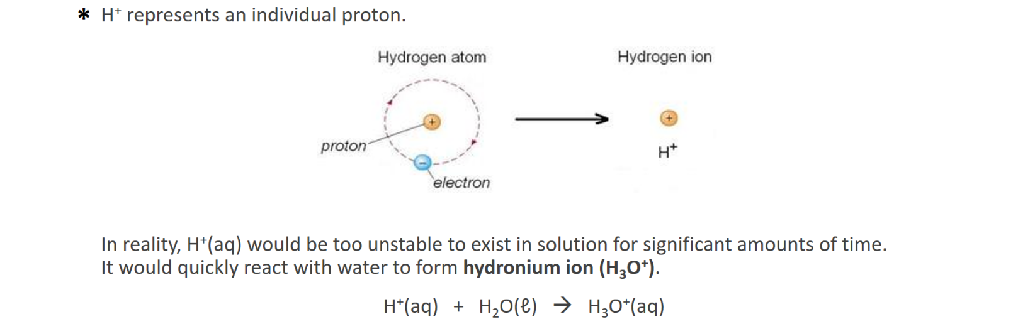

**EXPERIMENT: CONDUCTIVITY OF ACIDS AND BASES**

**Background:** Acids and bases are electrolytes, that is they conduct an electric current when in aqueous solution. For acids and bases electrolyte strength is also referred to as acid or base strength. Strong acids and bases exist essentially as ions in aqueous solution. Weak acids and bases are those in which only a small proportion of the molecules or ions react with water to form hydronium ions, H3O+ (hydrogen ion attached to a water molecule) or hydroxide ions, OH- in aqueous solution.

**Aim:** To investigate the electrical conductivity of acid and base solutions of different strengths and concentrations.

**Equipment:**

* Power supply
* Plate electrode system
* Ammeter
* Electrical leads (three)
* Two beakers
* 50 mL samples of the following solutions:
  + Hydrochloric acid 1 mol L-1
  + Hydrochloric acid 0.1 mol L-1
  + Hydrochloric acid 0.01 mol L-1
  + Hydrochloric acid 0.001 mol L-1
  + Nitric acid 1 mol L-1
  + Acetic acid 1 mol L-1
  + Sodium hydroxide 1 mol L-1
  + Ammonia 1 mol L-1

**Method:**

1. Set up the circuit and the electrodes as shown to the right.   
   Set the power supply to **6 V DC**.  
     
   **CAUTION:** Connect the red terminal of the power supply to the red terminal of the ammeter that uses the least sensitive scale. If the reading is less than the full scale reading of the next more sensitive scale switch the red terminal to use that more sensitive scale.
2. Place 50 mL of 1 mol L-1 HCℓ in a beaker, put the electrodes in the solution and briefly turn on the power pack.
3. Record the reading on the ammeter.
4. Wash out the beaker and electrodes with distilled water and then in turn test the conductivity of the other solutions.

**Results:**

|  |  |  |  |
| --- | --- | --- | --- |
| **Acid** | **Concentration  (mol L-1)** | **Acid/base strength  (strong or weak?)** | **Ammeter reading** |
| Hydrochloric acid (HCℓ) | 1 |  |  |
| 0.1 |  |  |
| 0.01 |  |  |
| 0.001 |  |  |
| Nitric acid (HNO3) | 1 |  |  |
| Acetic acid (CH3COOH) | 1 |  |  |
| Sodium hydroxide (NaOH) | 1 |  |  |
| Ammonia (NH3) | 1 |  |  |

**Questions:**

1. Explain why these solutions conduct an electric current

1. Look at your results for the HCℓ solutions. What conclusion can you draw regarding the conductivity of a solution and the concentration of ions in it?

1. Were the conductivities of 1.0 mol L-1 HCℓ and 1.0 mol L-1 CH3COOH different? If so, explain why they were different.

1. Were the conductivities of 1.0 mol L­-1 NaOH and 1.0 mol L-1 NH3 different? If so, explain why they were different.

1. Acids and bases are referred to as being ‘strong’ or ‘weak’ as distinct from being ‘concentrated’ or ‘dilute’. Explain how these two variables (electrolyte strength and solution concentration) affect the conductivity of aqueous solutions.

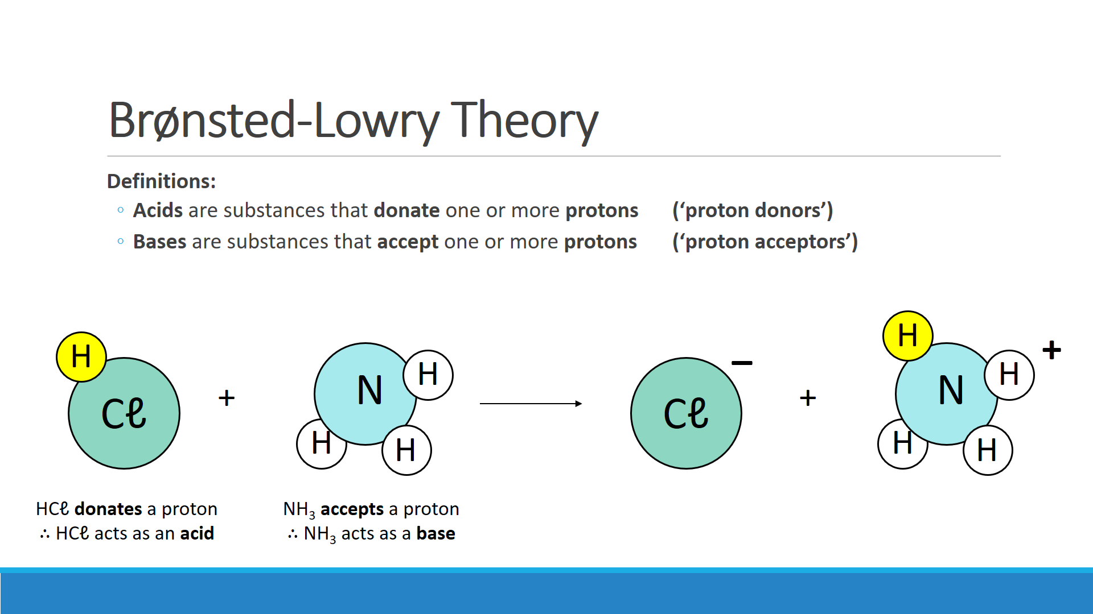

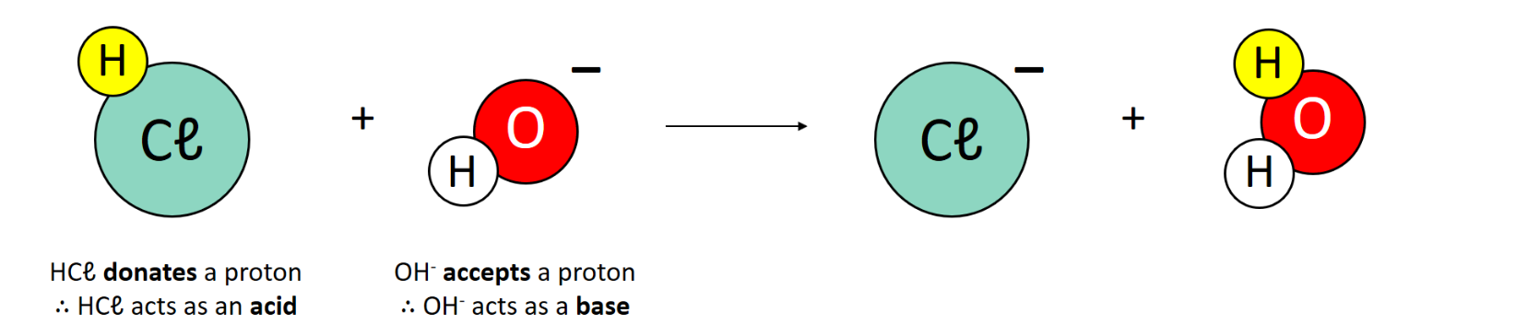

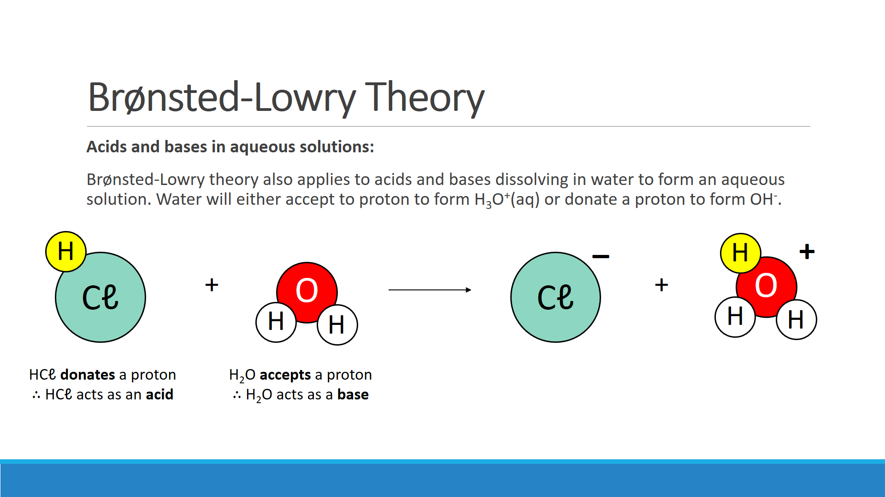

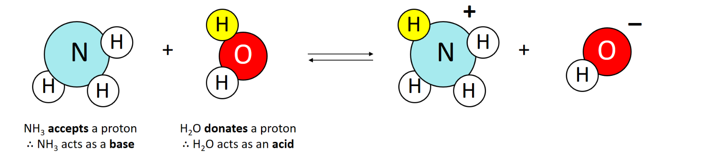



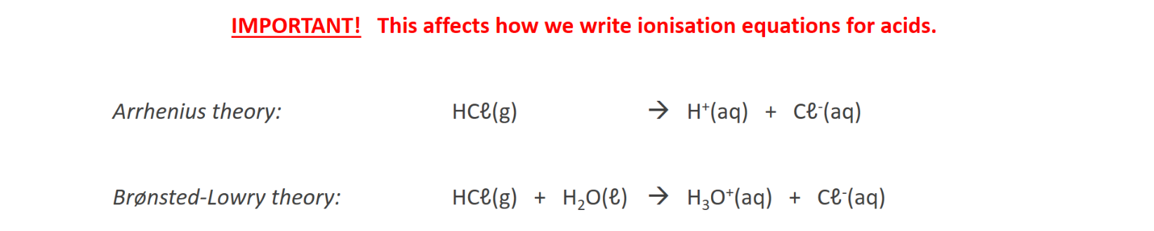

**Question:**

* Write an ionisation equation using Arrhenius theory
* Write an ionisation equation using Brønsted-Lowry theory

|  |  |
| --- | --- |
| **Nitric acid** | Arrhenius theory: |
| Brønsted-Lowry theory: |

|  |  |
| --- | --- |
| **Hydrofluoric acid** | Arrhenius theory: |
| Brønsted-Lowry theory: |

|  |  |
| --- | --- |
| **Carbonate ion**  *(weak base)* | Brønsted-Lowry theory: |

|  |  |
| --- | --- |
| **Methylamine (CH3NH2)**  *(weak base)* | Brønsted-Lowry theory: |

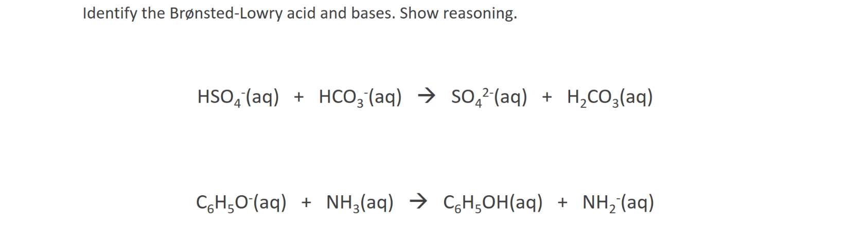

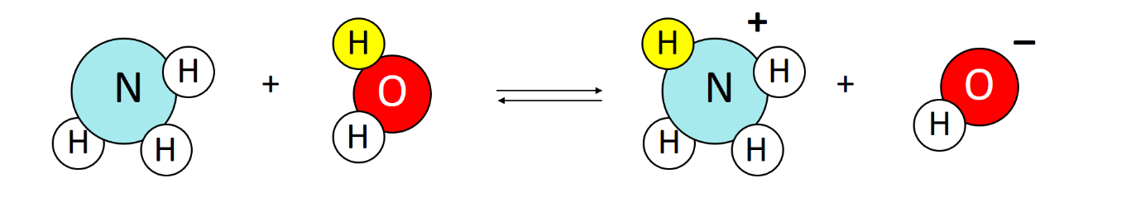

**____________ ___________ ___________ ___________**

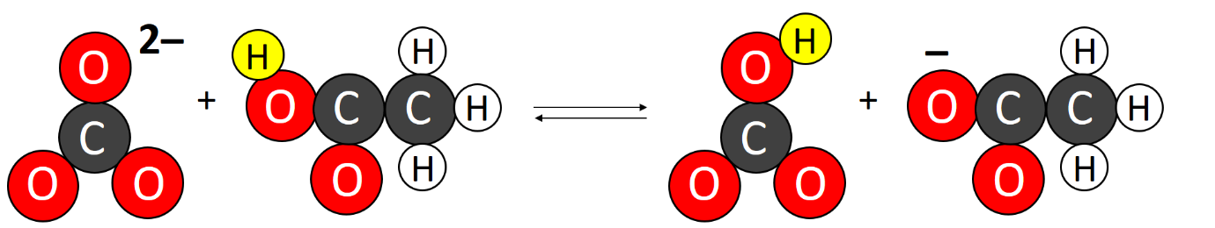

**____________ ___________ ___________ ___________**

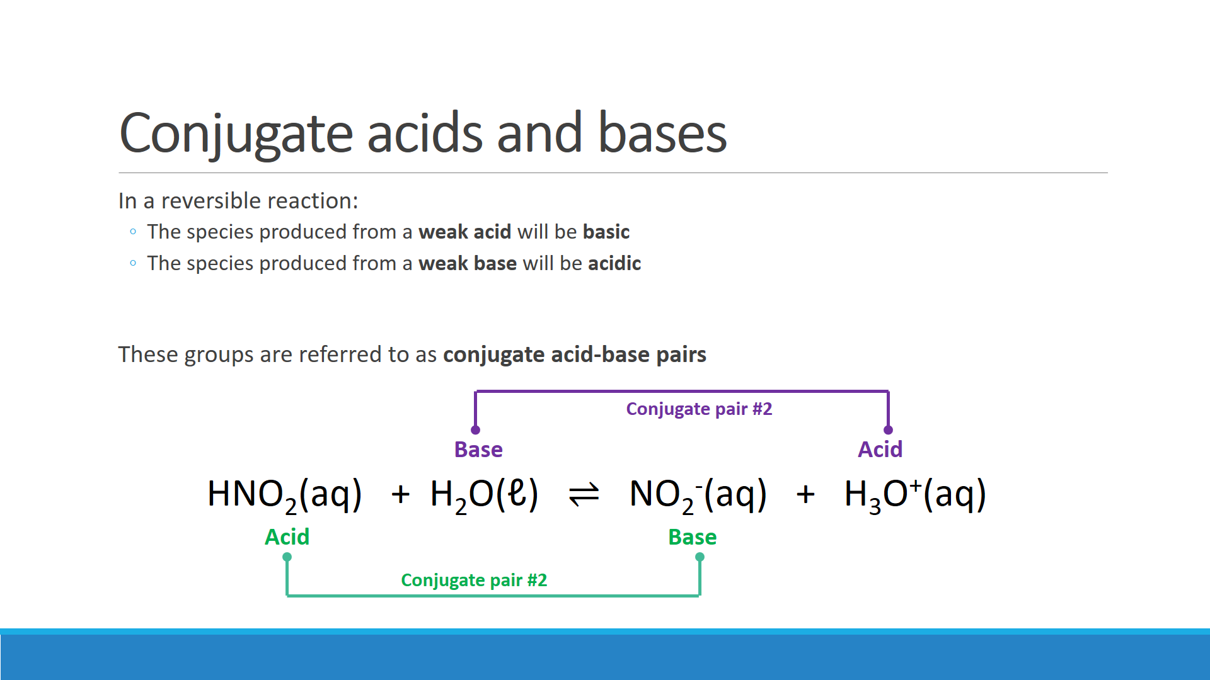

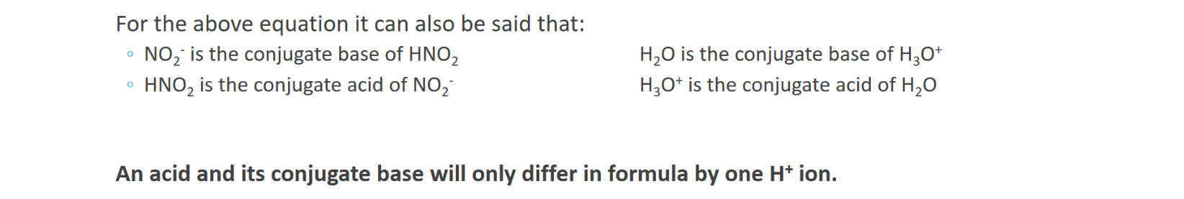

**Brønsted-Lowry review questions:**

1. Which of the following reactions are regarded as Brønsted-Lowry acid-base reactions?   
   For these reactions identify which reactant is acting as the Brønsted-Lowry acid and which is acting as the Brønsted-Lowry base.  
   1. SO32-(aq) + H2O(ℓ) ⇌ HSO3-(aq) + OH-(aq)
   2. HS-(aq) + NH3(aq) 🡪 NH4+(aq) + S2-(aq)
   3. H2O2(aq) + H2O2(aq) 🡪 2 H2O(ℓ) + O2(g)
   4. H2O(ℓ) + H2O(ℓ) ⇌ H3O+(aq) + OH-(aq)

1. Write equations for the dihydrogenphosphate ion reacting with water as a:  
   1. Brønsted-Lowry acid

* 1. Brønsted-Lowry base

1. The hydrogensulfide ion, HS-, is amphiprotic.
   1. What is meant by the word ‘amphiprotic’?

* 1. When HS- is added to hydrochloric acid, it acts as a Brønsted-Lowry base. Write the equation for the reaction between HS-(aq) and the hydronium ions in the hydrochloric acid.

* 1. HS- acts as a Brønsted-Lowry acid when it is added to a solution of sodium hydroxide. Write an equation for the reaction between HS-(aq) and the hydroxide ions in the sodium hydroxide solution

1. Complete the tables by giving the formula of the conjugate acids/bases.

|  |  |
| --- | --- |
| **Acid** | **Conjugate base** |
| HI |  |
| HNO2 |  |
| HCO3- |  |
| PH4+ |  |

|  |  |
| --- | --- |
| **Base** | **Conjugate acid** |
| SO32- |  |
| O2- |  |
| HF |  |
| NH3 |  |

1. Draw lines linking the conjugate acid-base pairs in the following reactions. Label each species as being an acid or a base.

HCN(g) + OH-(aq) ⇌ CN-(aq) + H2O(ℓ)

H2SO4(ℓ) + HNO3(ℓ) ⇌ H­3SO4+(ℓ) + NO3-(ℓ)

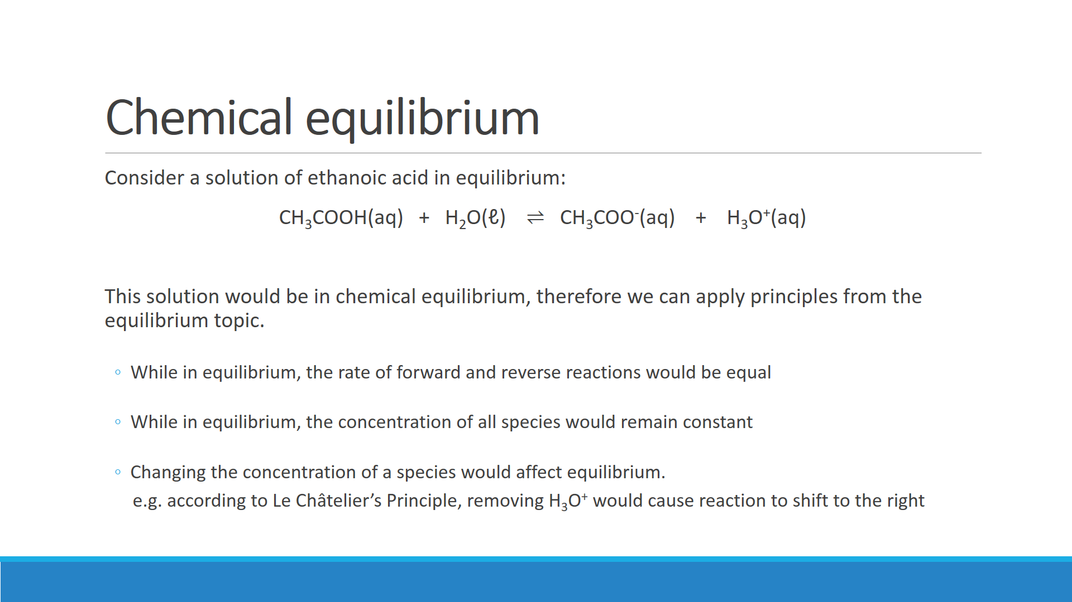

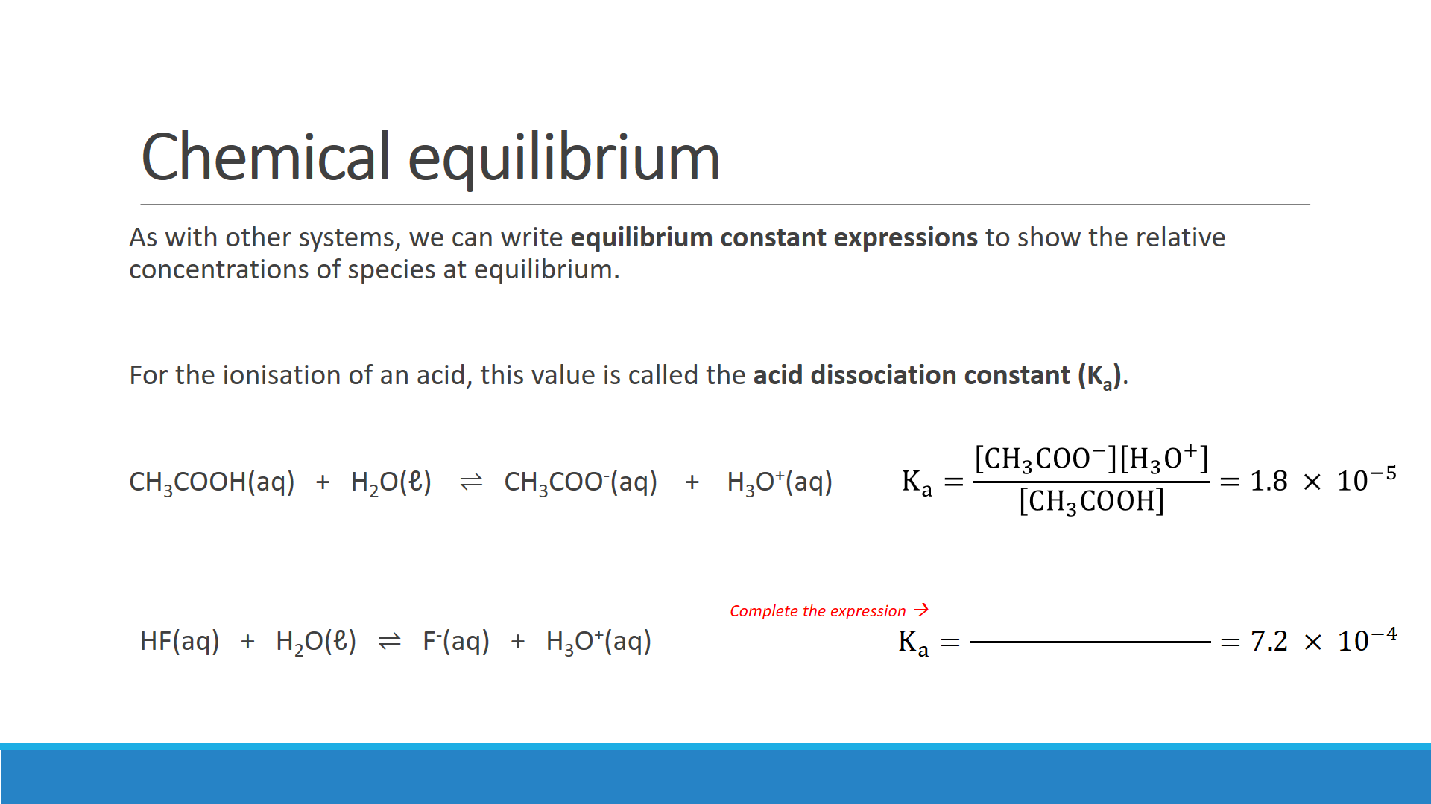

1. What does the size of the acid dissociation constant (Ka) for CH3COOH indicate about acetic acid?

1. What do the Ka vales of CH3COOH and HF indicate about their *relative* strengths? Justify your answer.

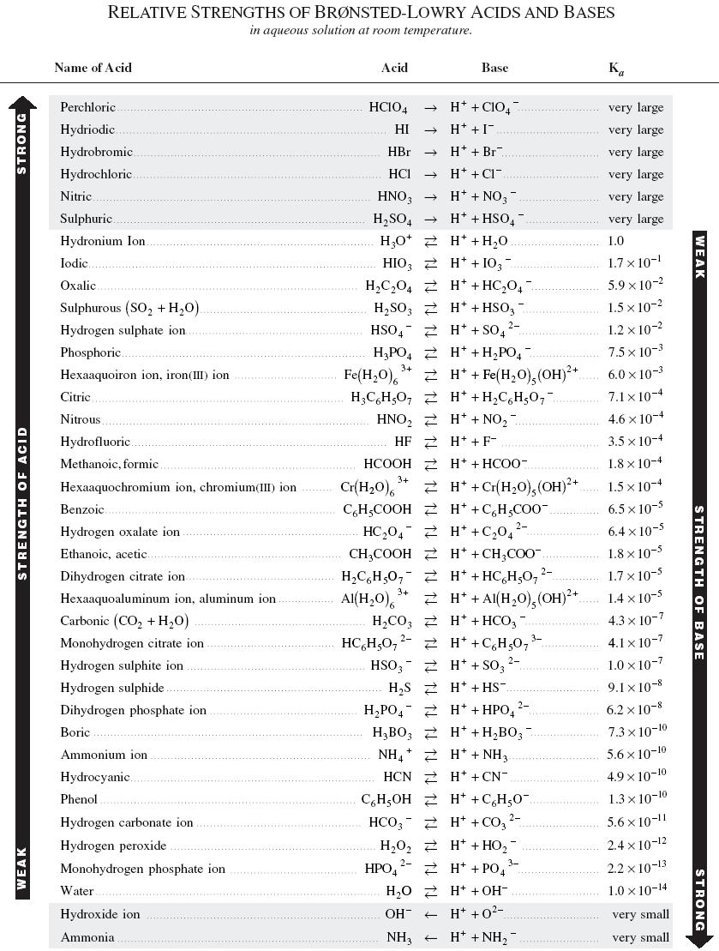

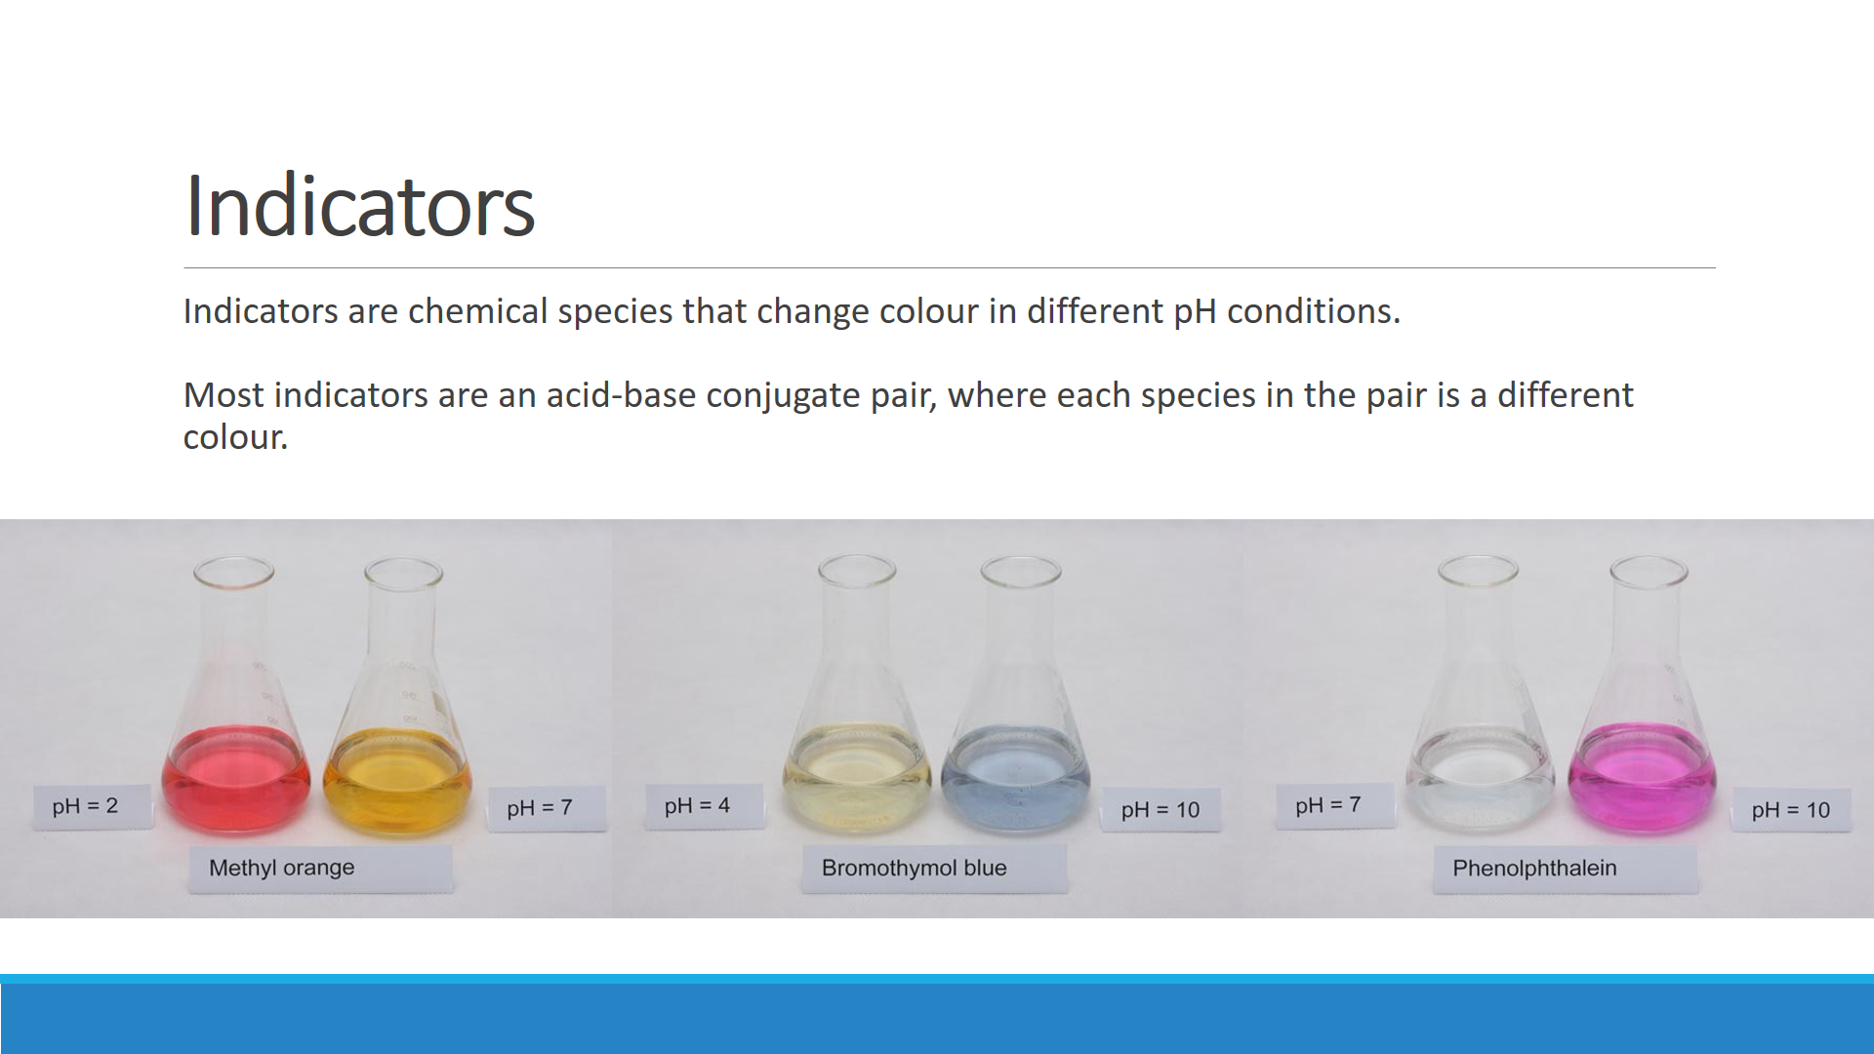

**(Use a highlighter to show appropriate colour for each indicator)**

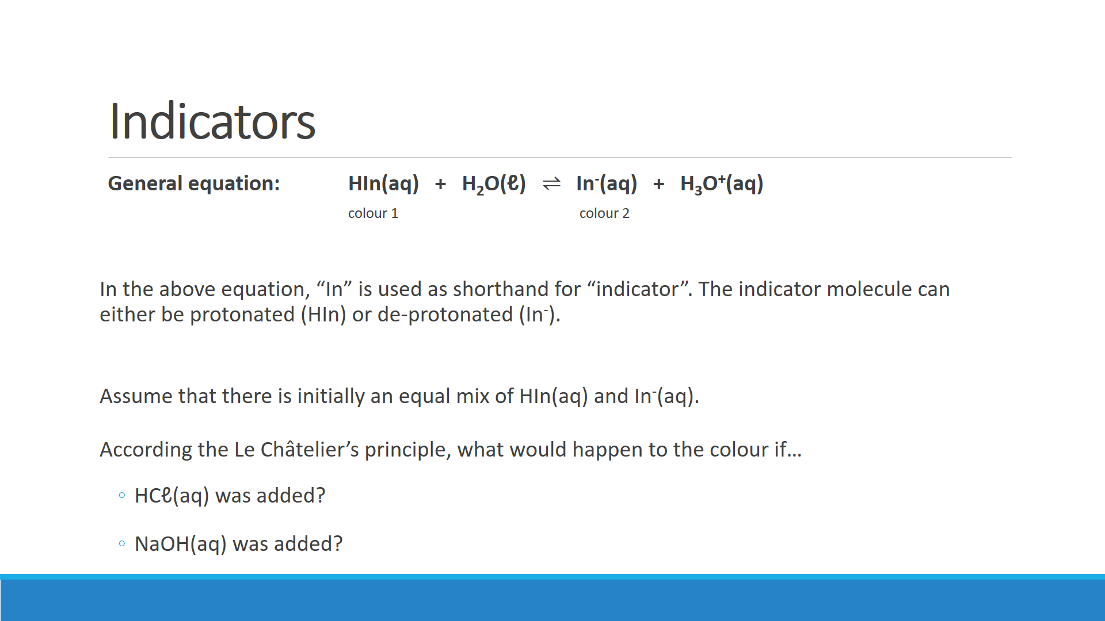

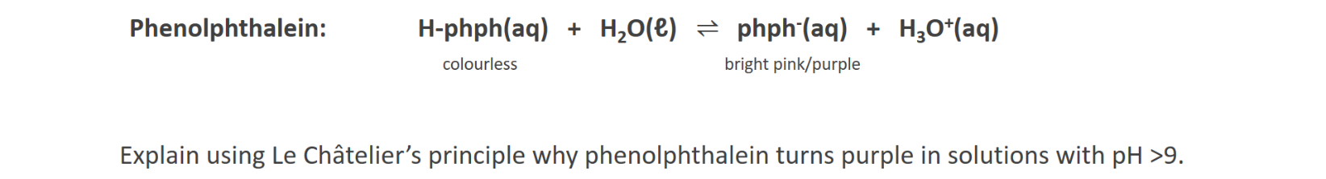

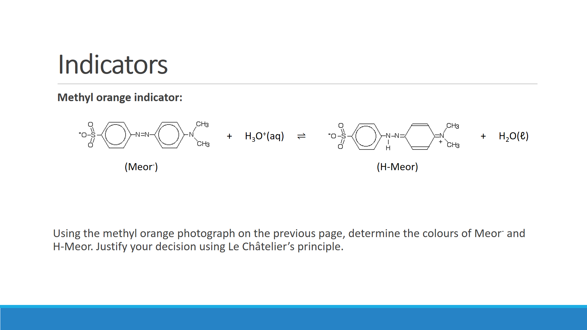

**This image won’t work in black-and-white.   
You will need to colour it in yourself.**

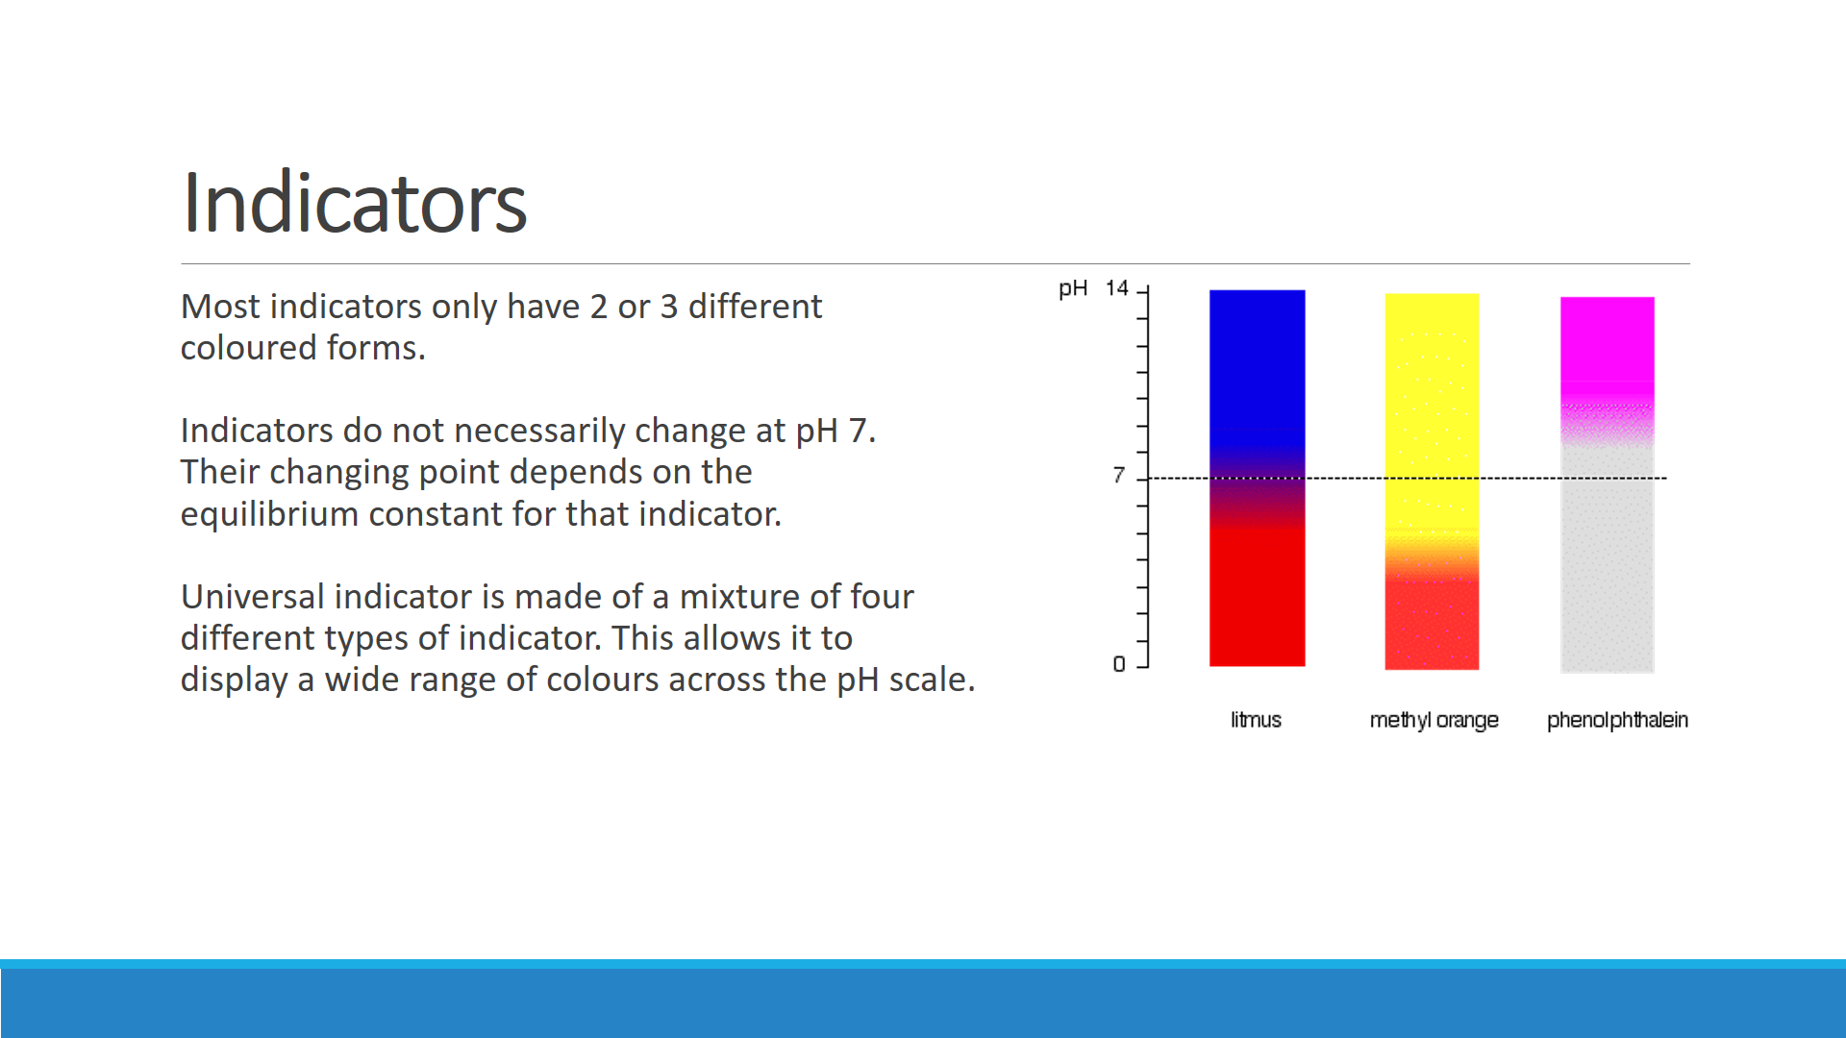

**Q:** To determine the pH of garden soil, a sample was first saturated with distilled water in a petri dish. Drops of three indicators listed below were added to separate parts of the sample. The colours observed are shown in the table.

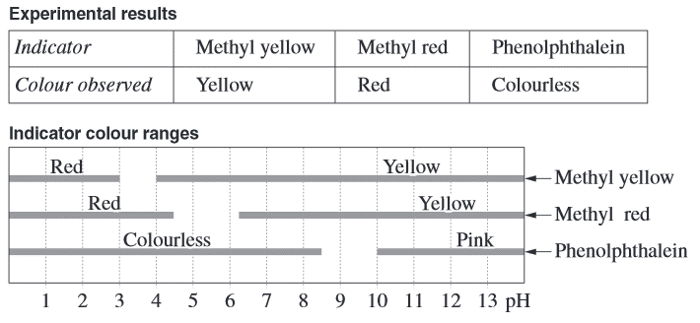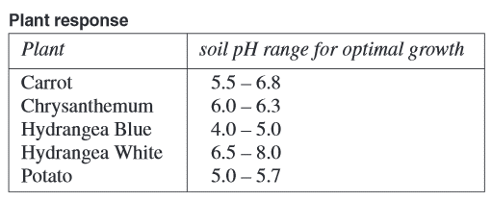

Using the information given, select the plant that will grow well at the current soil pH, and justify your selection.

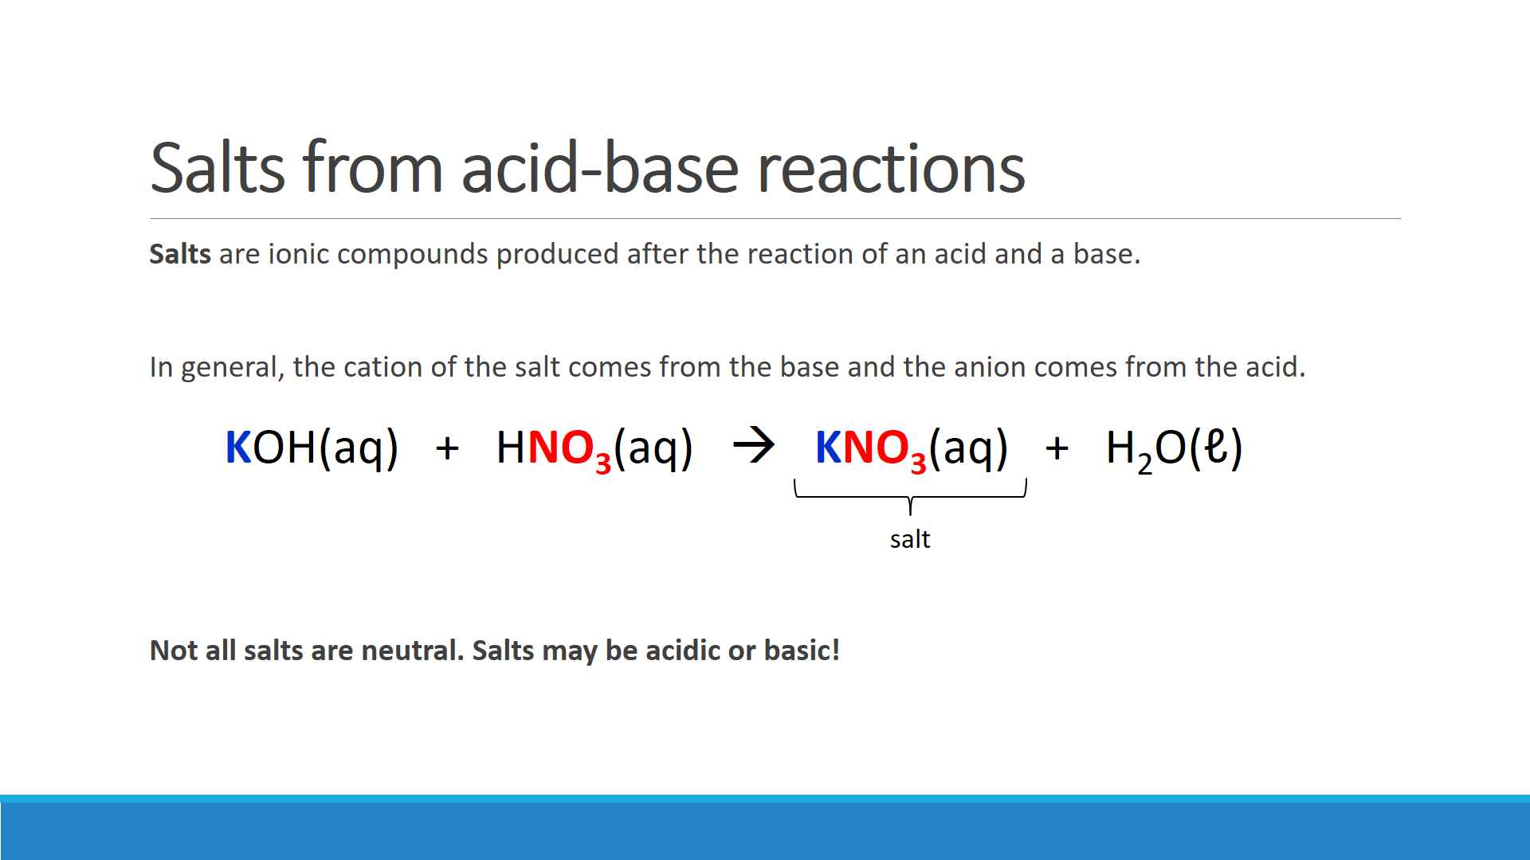

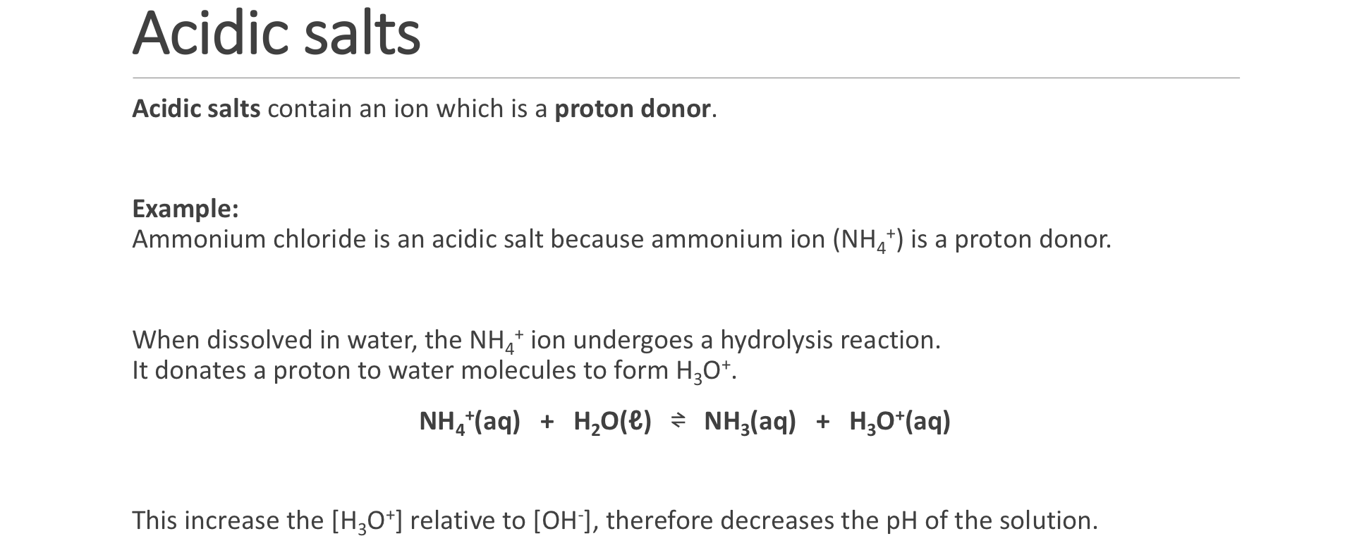

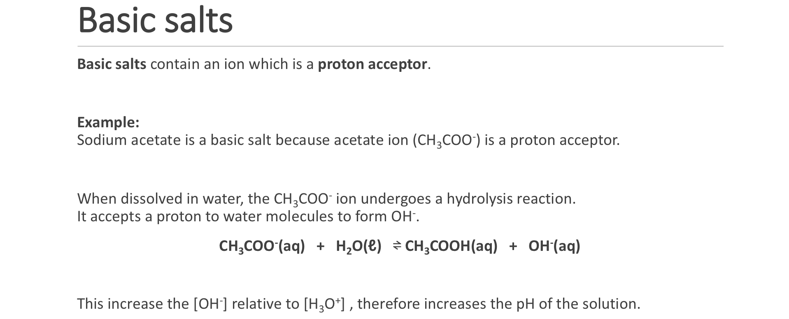

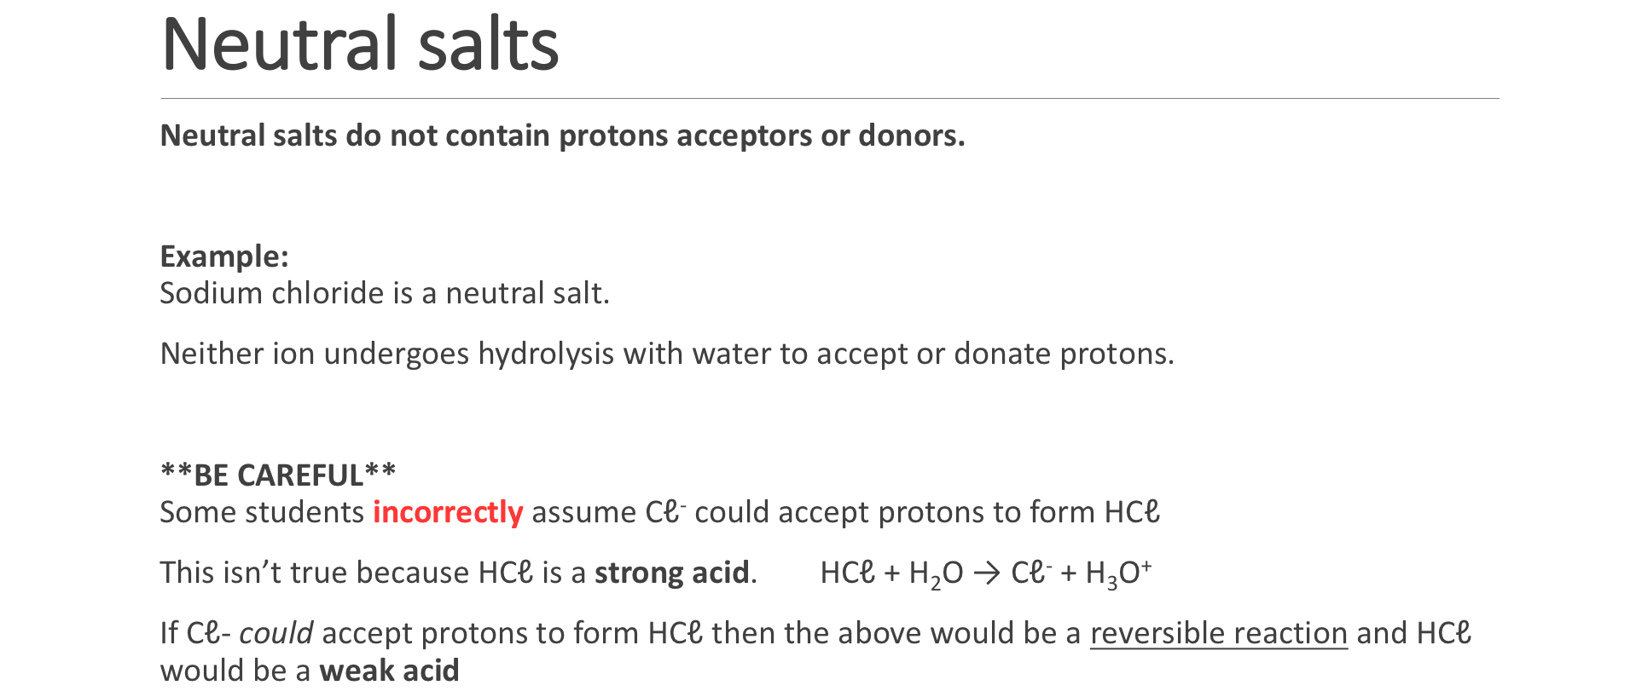

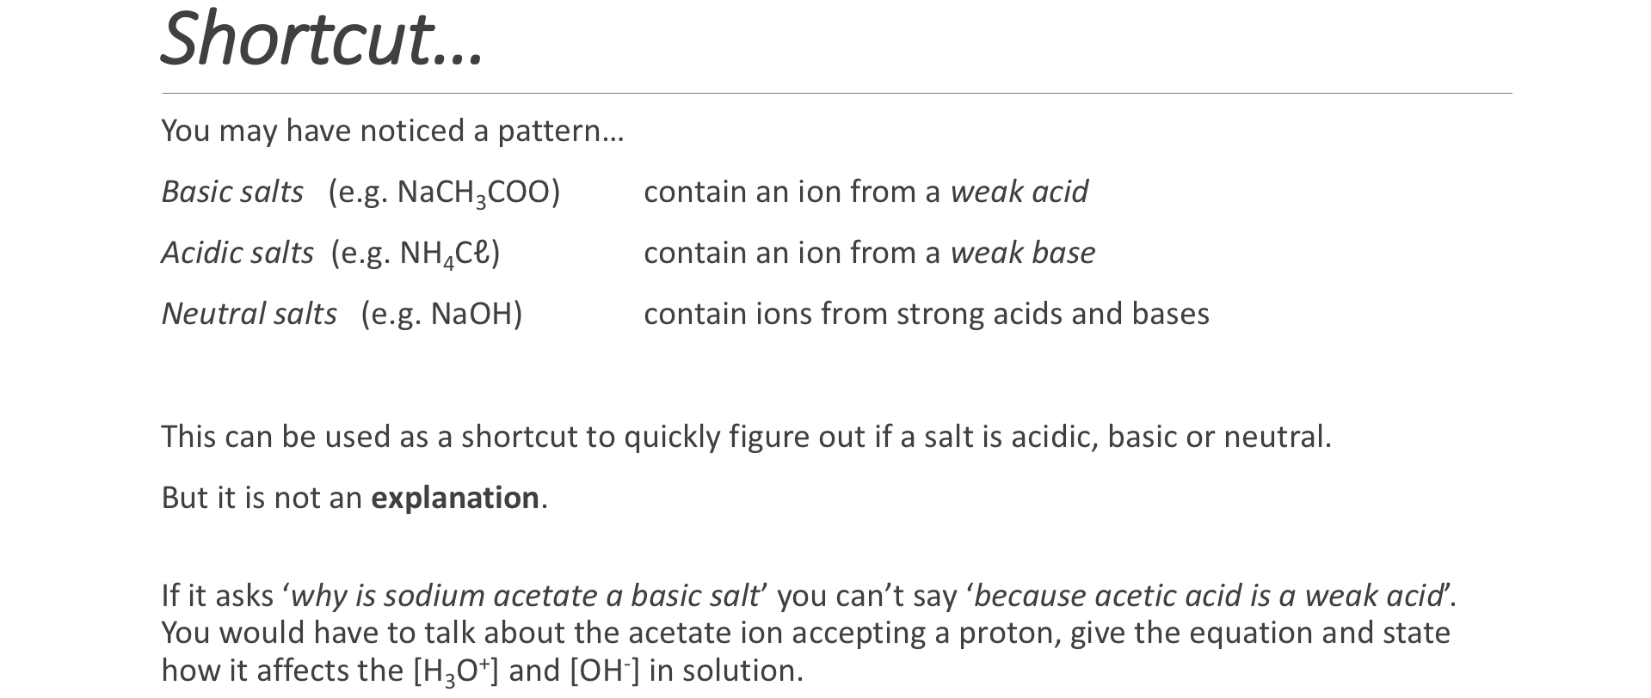

**Classify the following salts as acidic, basic or neutral. If it is acidic or basic, include an appropriate hydrolysis equation.**

|  |  |  |
| --- | --- | --- |
| **Salt** | **Acidic, basic or neutral** | **Hydrolysis equation** |
| NaNO3 |  |  |
| NaF |  |  |
| NH4NO3 |  |  |
| KI |  |  |
| Na3PO4 |  |  |
| CaCO3 |  |  |
| MgBr |  |  |
| NaCℓO | Basic |  |

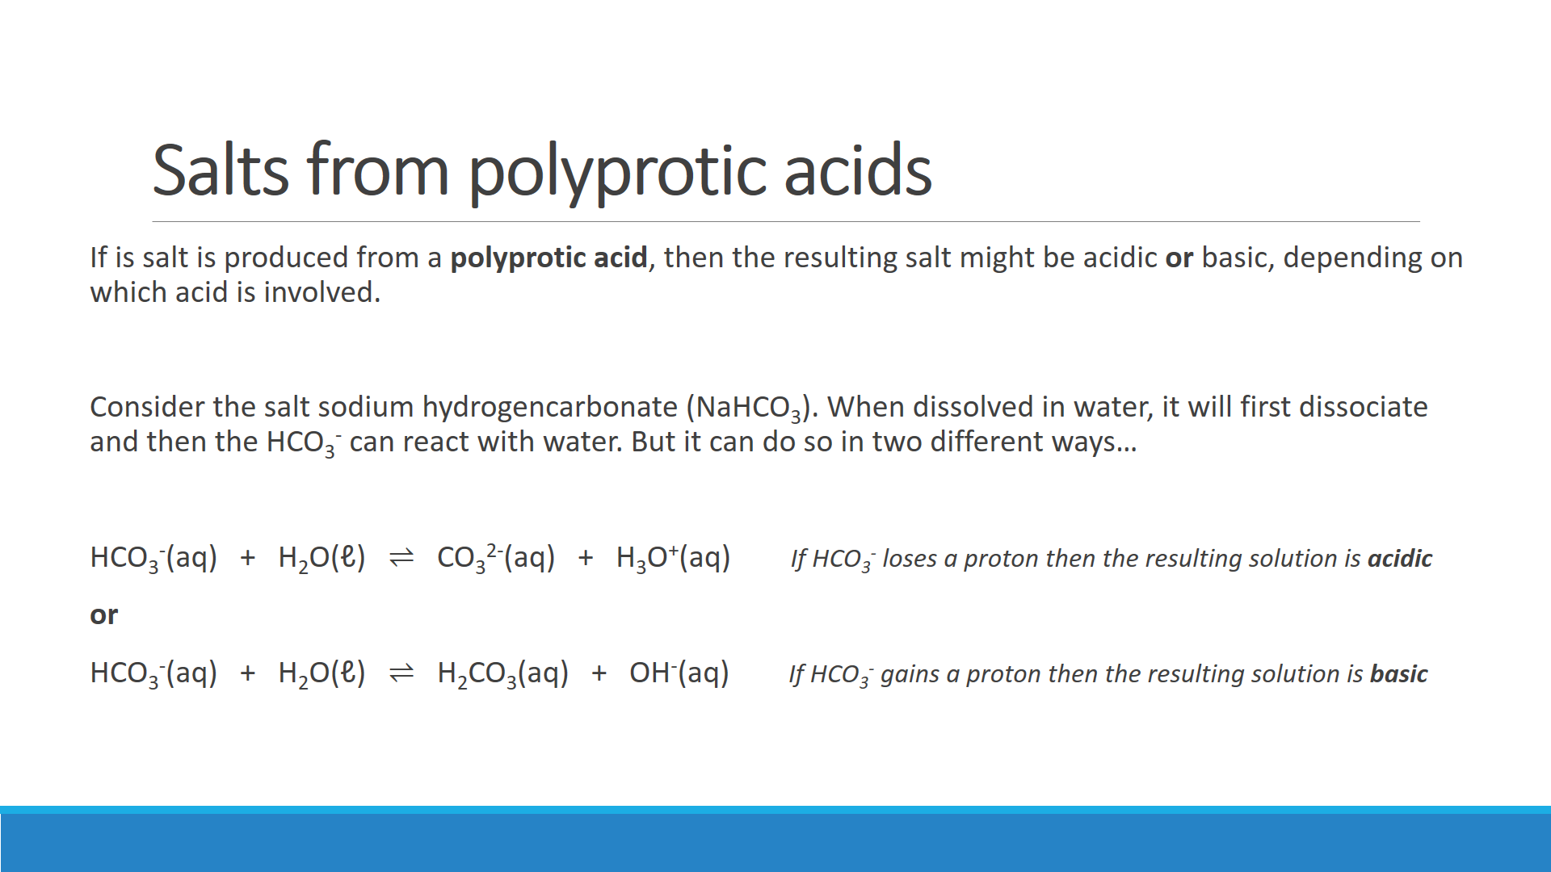

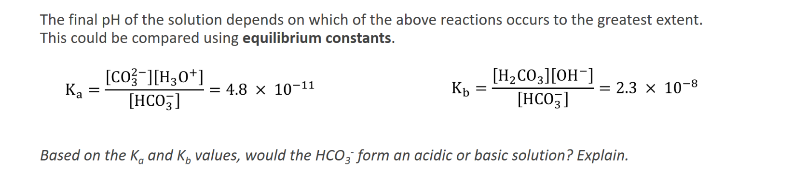

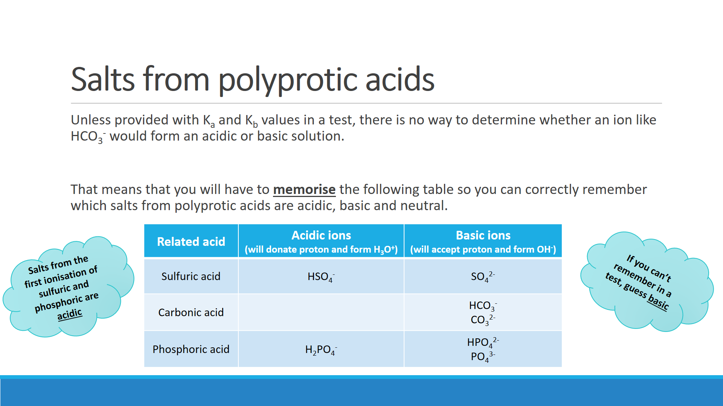

**Questions:**

1. a) Predict whether a sample of sodium hydrogensulfate (NaHSO4) will be acidic or basic.

b) Write a hydrolysis equation showing the reaction that results in the above acidity or basicity.

c) Use the equation above to explain why the pH of water changes when NaHSO4 is dissolved in it.

1. Potassium hydrogenphosphate (Na2HPO4) is basic, whereas potassium dihydrogenphosphate (NaH2PO4) is acidic.   
   Use the concept of acid and base dissociation constants to explain this difference.

1. Ammonium carbonate dissolve in water as follows:

(NH4)2CO3(s) 🡪 2 NH4+(aq) + CO32-(aq)

Following dissociation, two further reactions occur as follows:

NH4+(aq) + H2O(ℓ) ⇌ NH3(aq) + H3O+(aq)

CO32-(aq) + H2O(ℓ) ⇌ HCO3-(aq) + OH-(aq)

Indicators show that an aqueous solution of (NH4)2CO3 is basic. Explain this fact in view of the fact that there are twice as many NH4+ ions (which may produce H3O+) as there are CO32- ions (which may produce OH-) in any sample of ammonium carbonate.

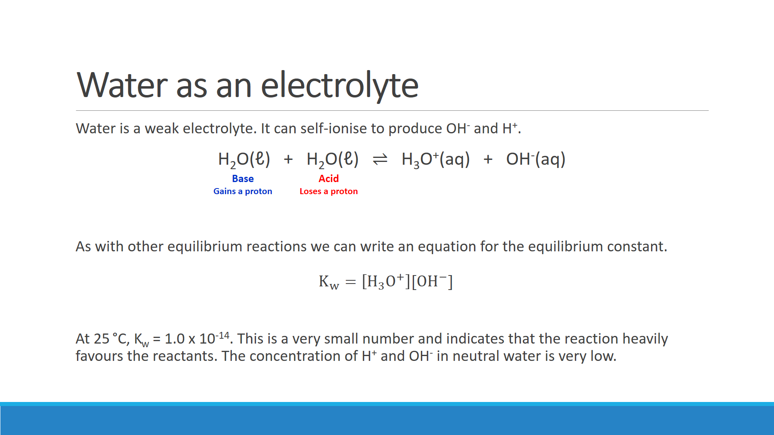

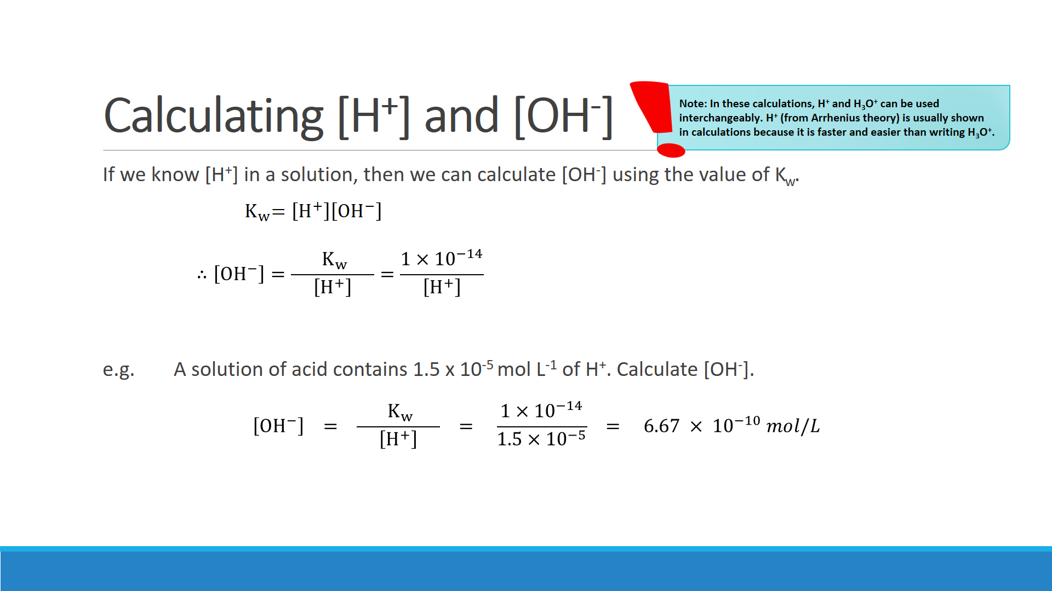

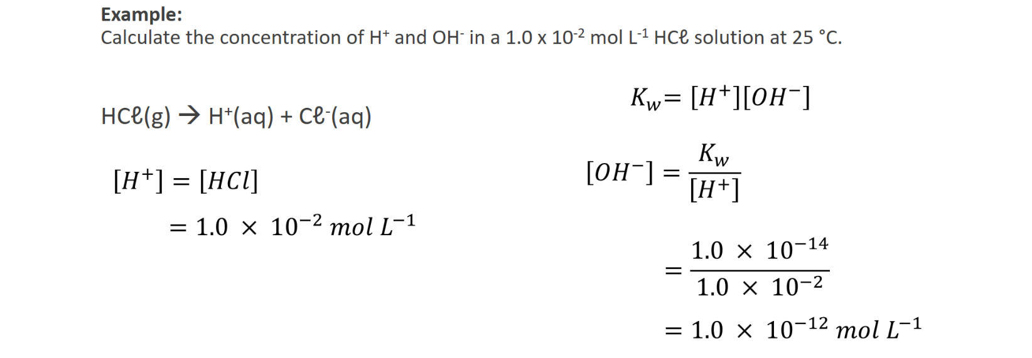



**Questions – Calculating [H+] and [OH-]**

1. The concentation of acid and base in a swimming pool is critical to maintaining an adequate level of chlorine in the water. The concentration of hydrogen ions in the water of an olympic swmming pool was measured to be 1.48 x 10-7 mol L-1. Calculate the concentration of hydroxide ions.

1. Water in the tailings dam of a gold processing plant was found to have a hydroxide ion concentration of 1.58 x 10-4 mol L-1. Calculate [H+].

1. Calculate the hydrogen ion concentration in the following solutions.
2. A standard 1.55 x 10-4 mol L-1 sodium hydroxide solution used for analysing the acid content of wine.

1. A 3.90 x 10-2 mol L-1 barium hydroxide solution used to make soap. **Careful!** **This calculation involves a sneaky trick!**

1. A 0.125 mol L-1 sulfuric acid solution is used to dissolve samples of of malachite. Assume that the first hydrogen is fully ionised and the second hydrogen is 10.0% ionised. Calculate the concentration of **hydroxide ions** in the solution.

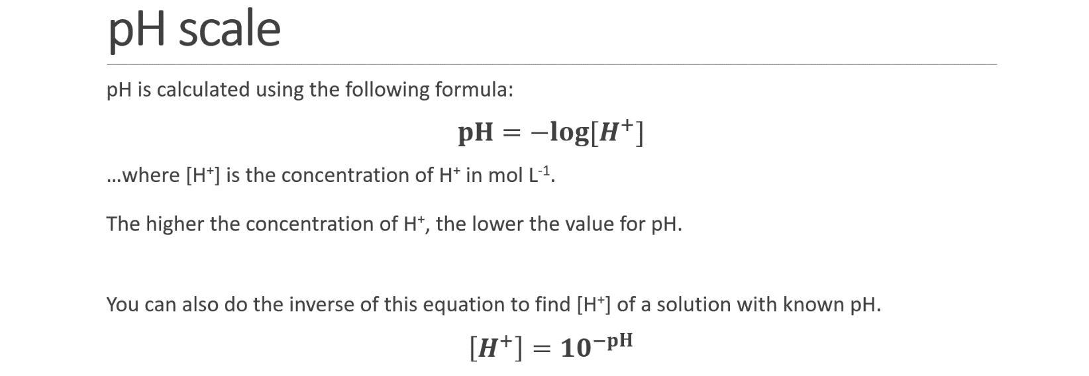

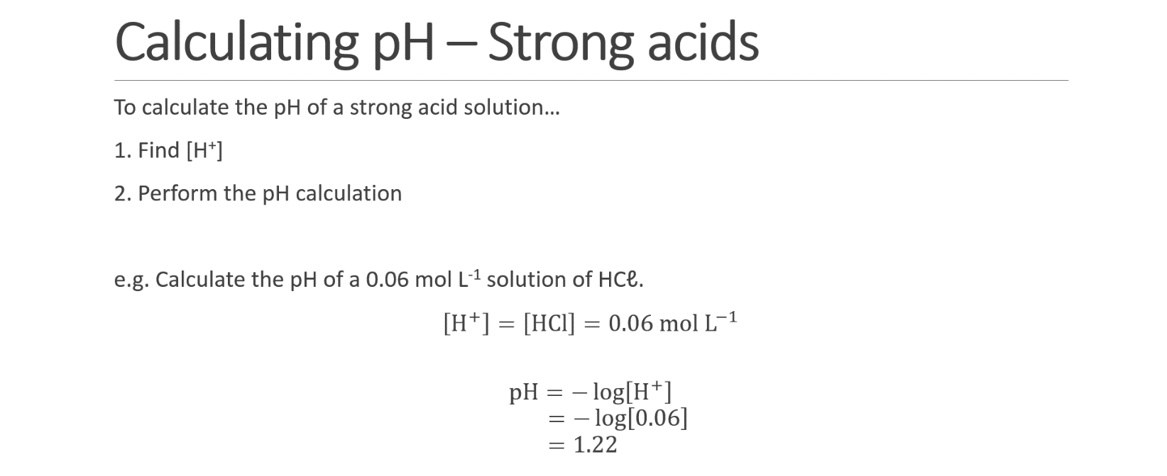

**Q:** Calculate the pH of a 5.0 x 10-3 mol L-1 solution of HNO3

**Q:** 2 litres of hydrogen chloride gas (HCℓ) is collected at **S.T.P.** and is dissolved in 500 L of water. Calculate the pH of the resulting solution.

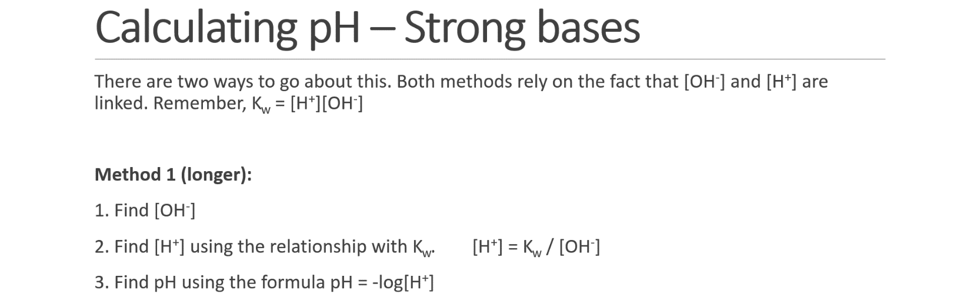

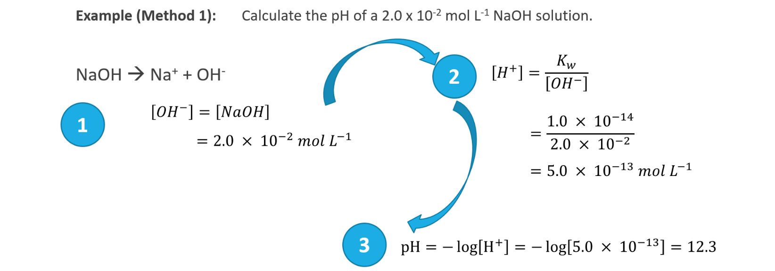

**Q:** Calculate the pH of the following solution using **Method 1** shown above:

1. A 0.0065 mol L-1 solution of KOH

1. A 6.5 x 10-4 mol L-1 solution of Ba(OH)2 **Be careful when calculating [OH-]**

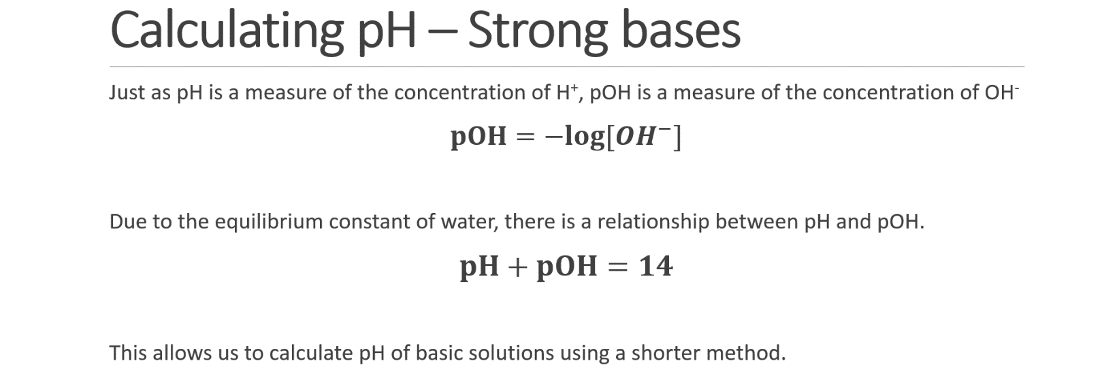

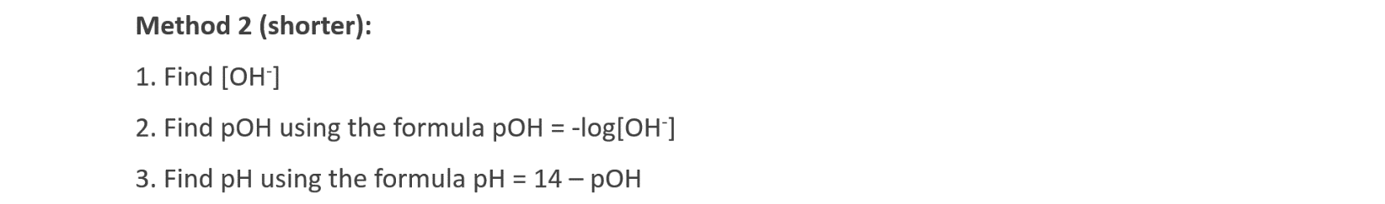

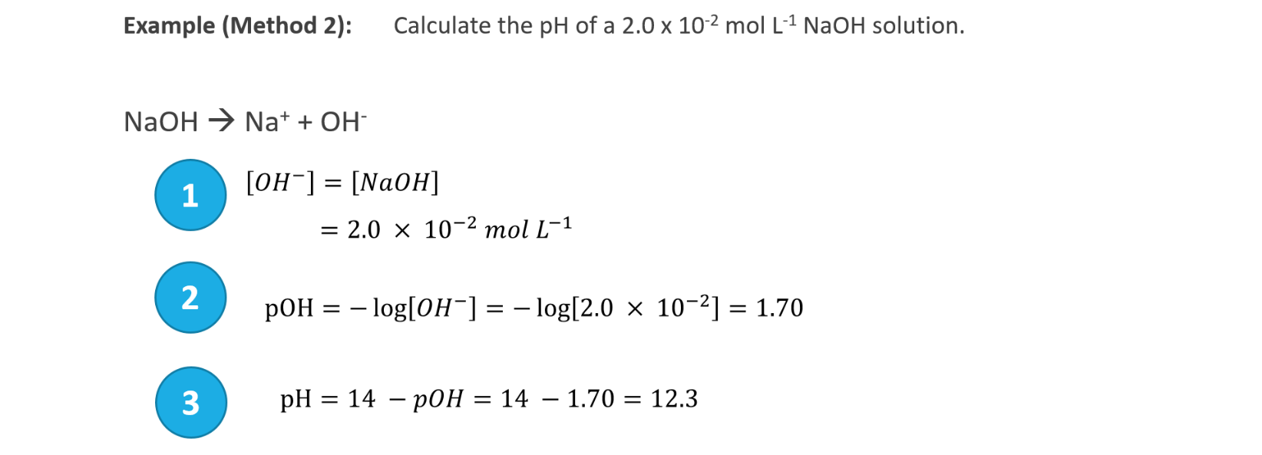

**Q:** Calculate the pH of the following solution using **Method 2** shown above:

1. A 0.000024 mol L-1 solution of KOH

1. A 7.5 x 10-2 mol L-1 solution of Ba(OH)2 **Be careful when calculating [OH-]**

**Questions – pH calculations**

1. Calculate the [H+], [OH-] and pH of the following solutions.
   1. A 0.00500 mol L-1 HNO3 solution used to reduce the pH of nutirent solutions used for hydroponics

* 1. A 0.0100 mol L-1 standard NaOH solution used to analyse vinegar solutions

* 1. A 2.00 mol L-1 HCℓ solution used to dissolve limestone prior to analysis

1. Calculate the [H+] and [OH-] of solutions with the following pH:
   1. Lemon juice of pH 3.00

* 1. Dish washing solution of pH 11.0

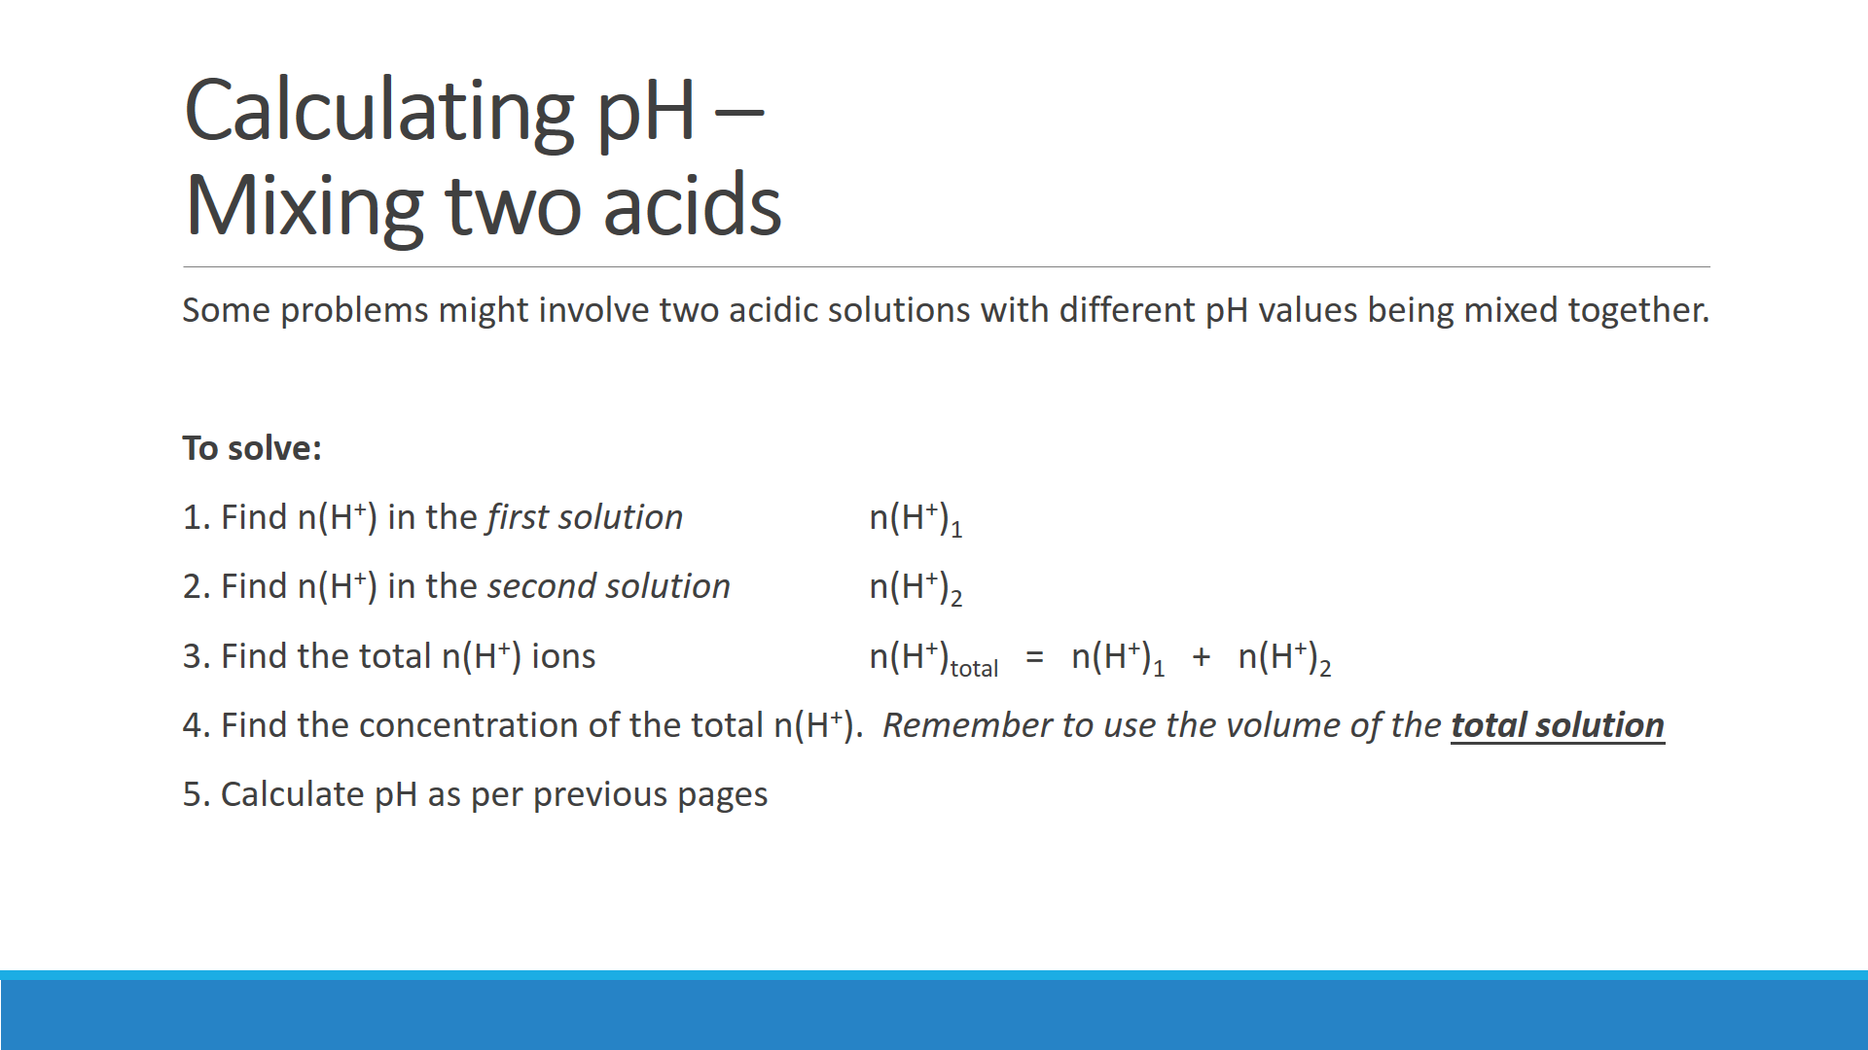

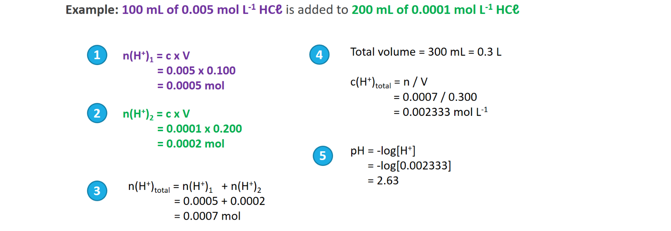

**Question – Mixing acids**

A brick cleaner needs to replenish the hydrochloric acid solution he is using. Using a pH meter he measures the pH of his depleted solution to be 2.00. He decides to add 3.00 L of 3.00 mol L-1 HCℓ solution to 2.00 L of his solution. Calculate the pH of the new solution.

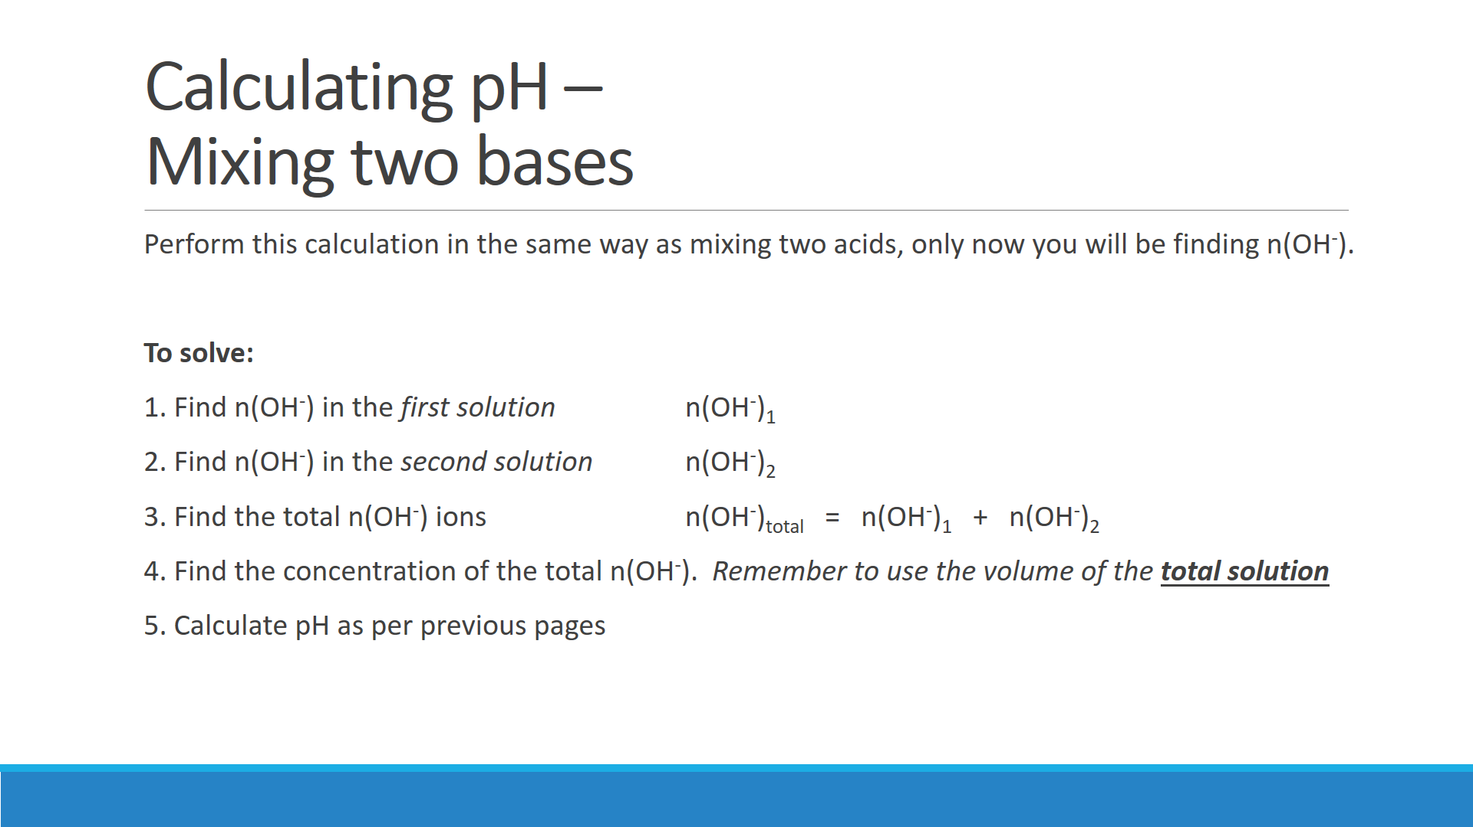

**Question – Mixing bases**

An environmental chemist is conducting research into highly alkaline solutions found in a drain near a concrete batching plant. The concentration of the solution from the drain was found to be 0.236 mol L-1 hydroxide ion and the runoff from the plant was found to have a concentration of hydroxide ion of 0.156 mol L-1. The chemist mixed 200 mL of the solution from the drain with 300 mL of the runoff from the plant.

Calculate the pH of the resulting solution:

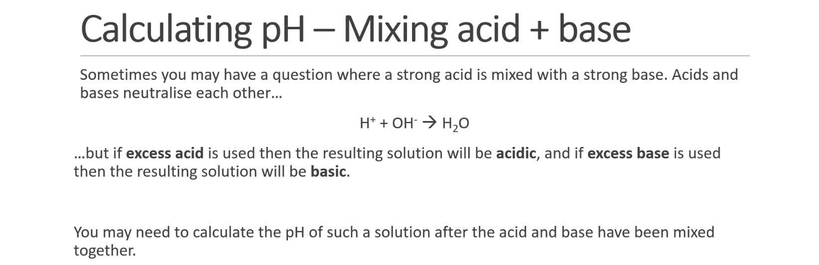

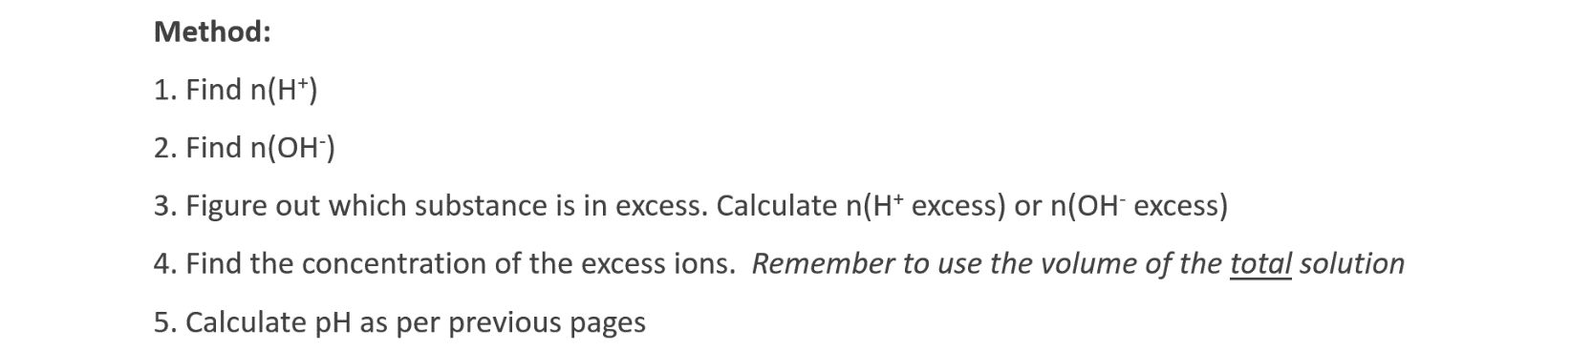



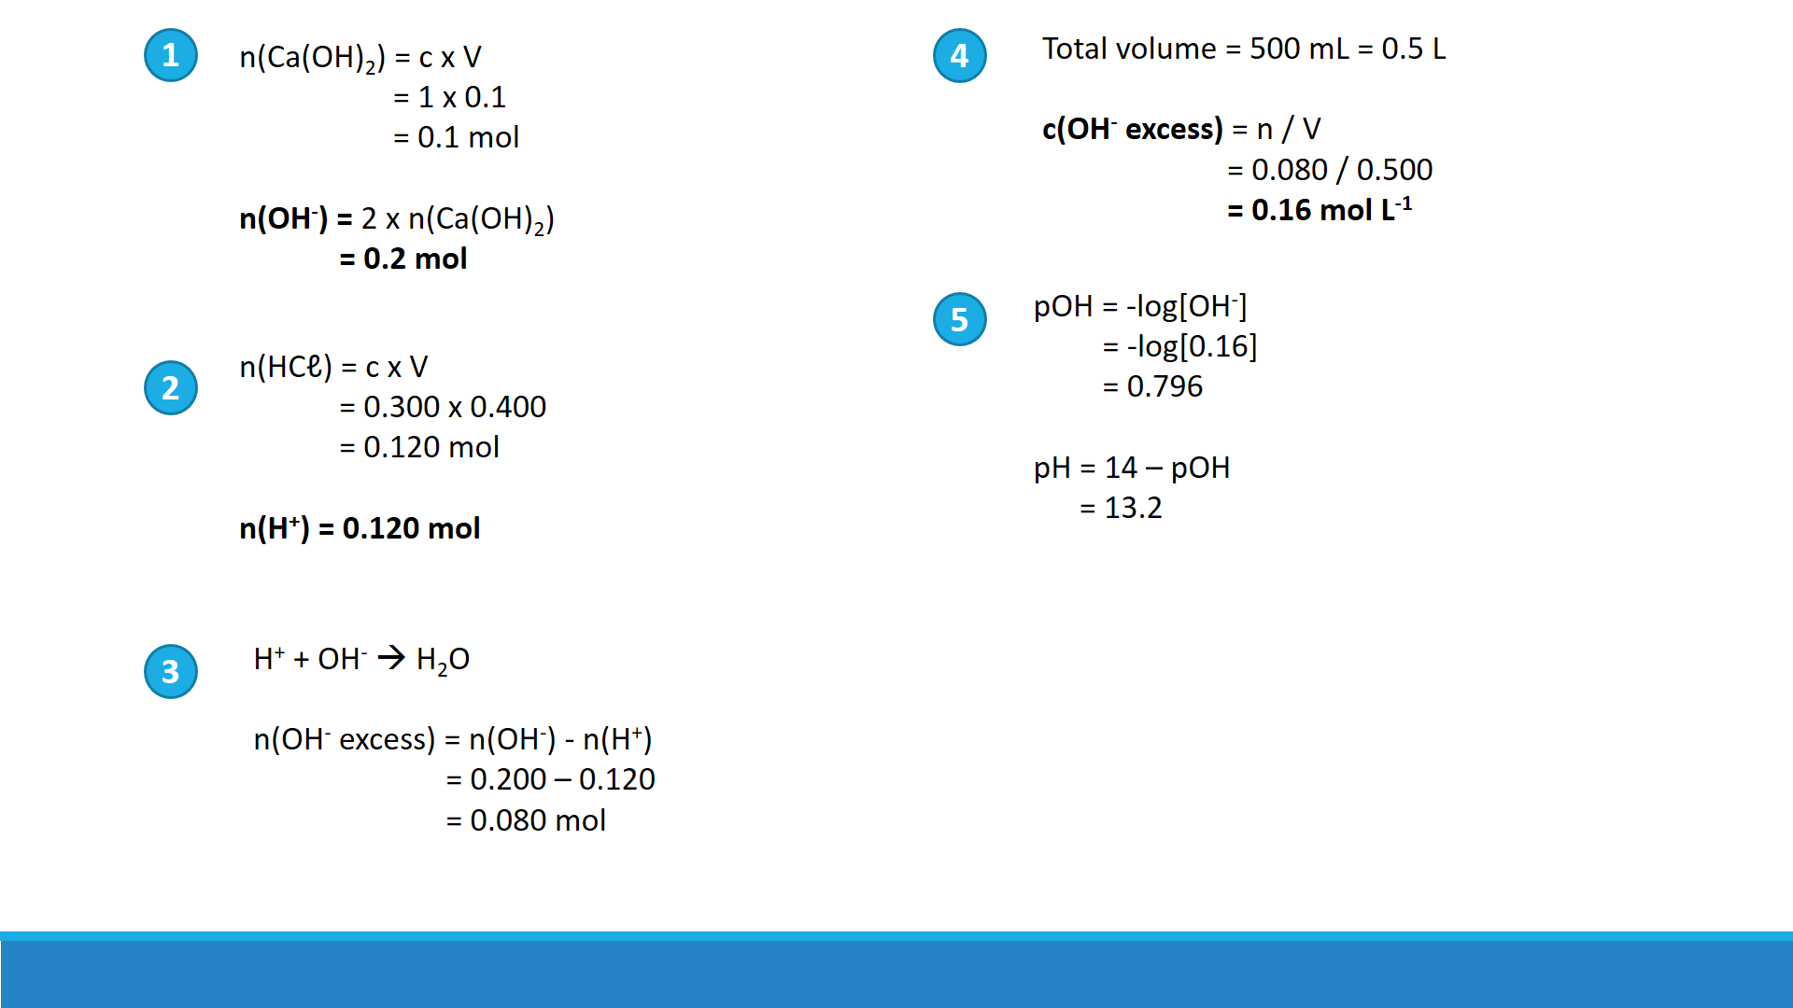

**Questions – Mixed acid-base pH calculations**

Calculate the pH when the following solutions are mixed:

1. 200 mL of 0.1 mol L-1 sodium hydroxide and 300 mL of 0.1 mol L-1 hydrochloric acid

1. 200 mL of 0.1 mol L-1 sodium hydroxide and 300 mL of 0.1 mol L-1 sulfuric acid

1. When you suffer from an acid stomach, the fluid in your stomach can contain hydrochloric acid at a concentration of 2.50 x 10-4 mol L-1. To reduce the amount of acid in your stomach you are advised to take an antacid tablet that contains 5.00 mg of aluminium hydroxide and 5.00 mg of magnesium hydroxide. If at this time you have 1.50 L of fluid in your stomach, calculate the [H+], [OH-] and pH of your stomach after you have taken the tablet. Assume that the presence of the tablet does not change the volume of the solution in your stomach.

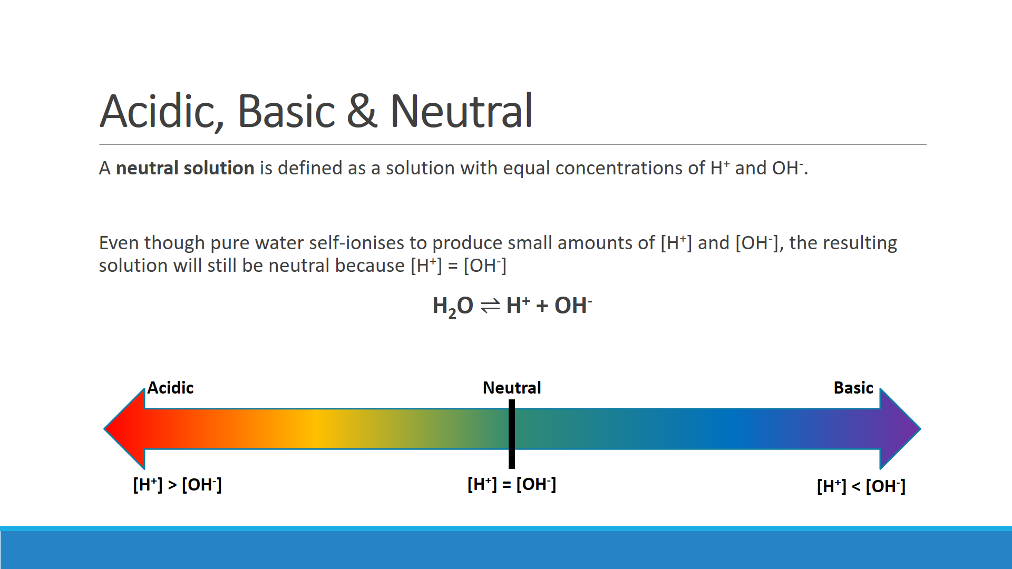

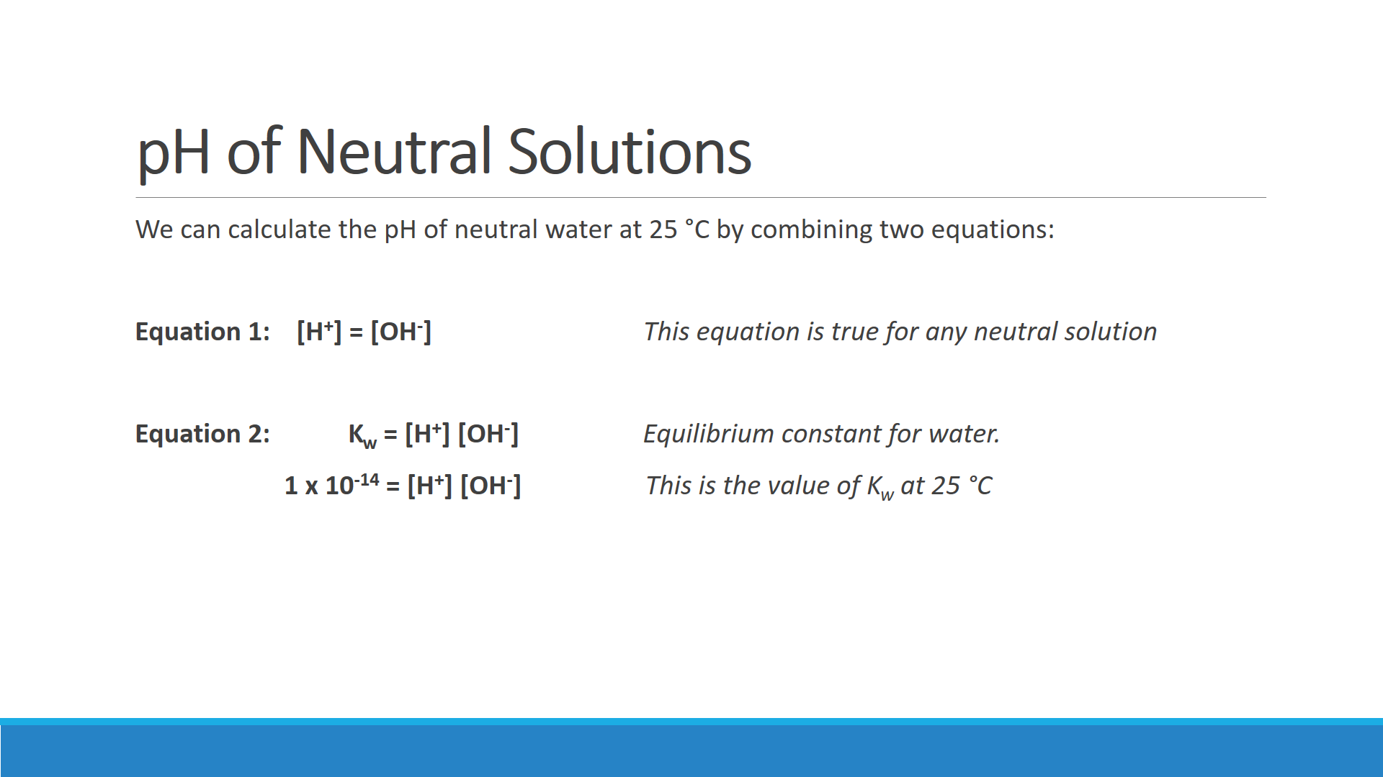



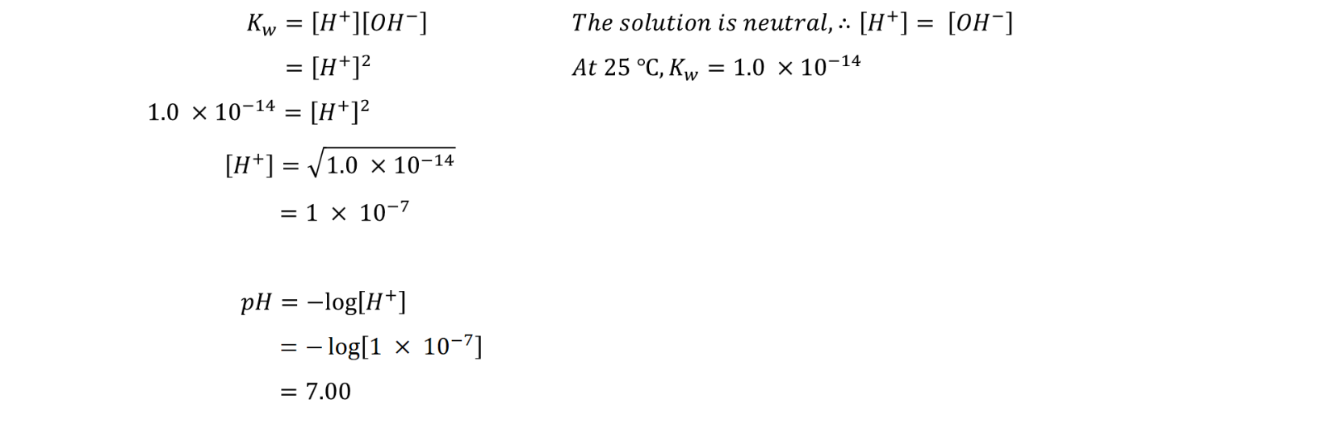

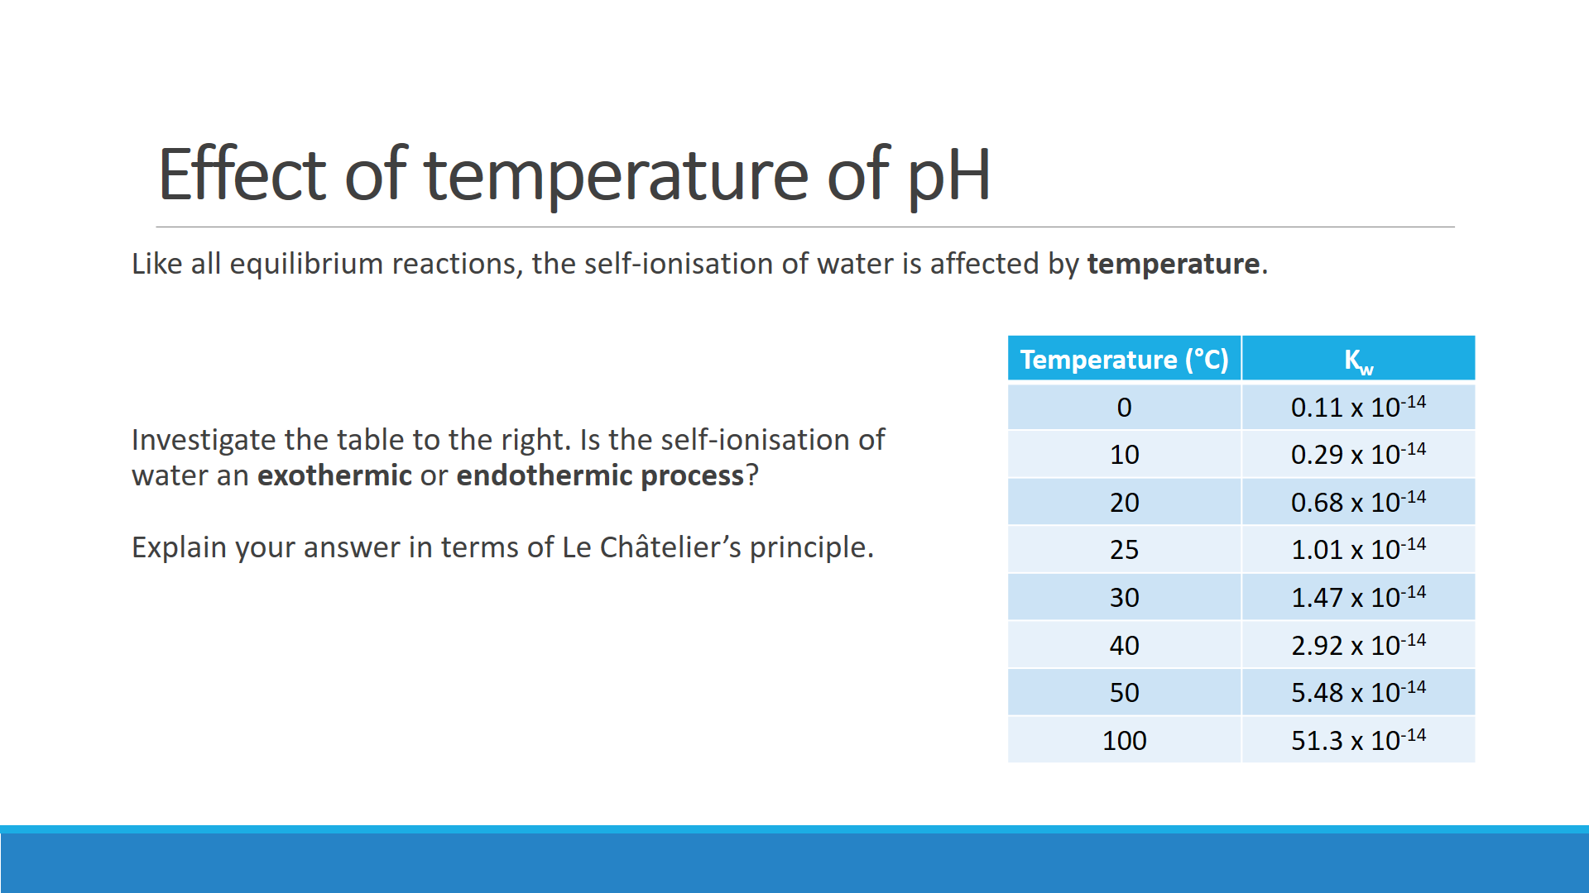



**Q:** Calculate the pH of water at the following temperatures. Use the Kw values from the table above.

1. Neutral water at 10 °C

1. Neutral water at 50 °C

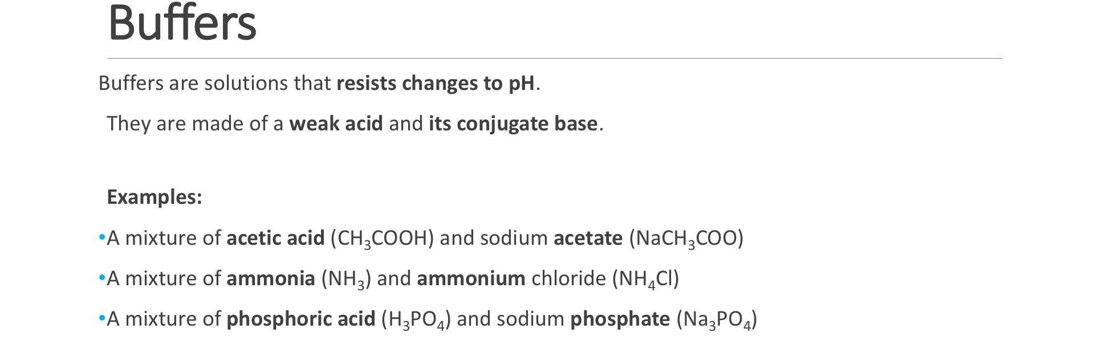

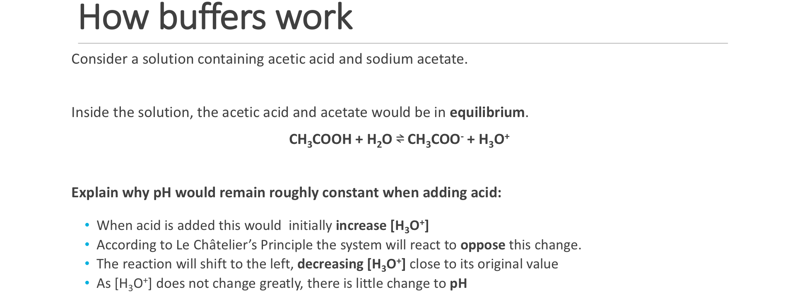

Use Le Châtelier’s principle to explain why pH does not change when sodium hydroxide is added to a mixture of acetic acid and sodium acetate.

Use Le Châtelier’s principle to explain why pH does not change when acid is added to a mixture of sodium hydrogencarbonate and sodium carbonate.

Explain why a mixture of nitric acid and sodium nitrate would **not** make a good buffer.

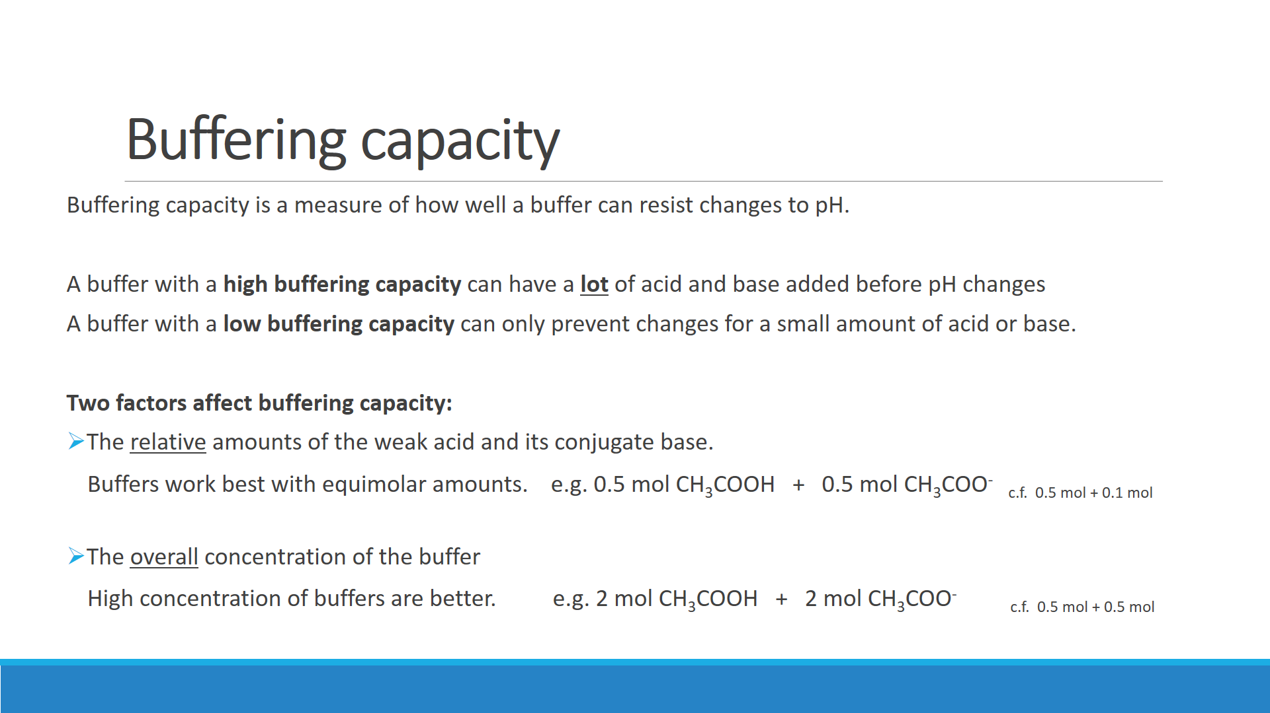

Water contains H3O+ ions and OH- ions due to the self-ionsation of water. 2 H2O(ℓ) ⇌ H3O+(aq) + OH-(aq).

Adding acid or base to pure water would cause this equilibrium system to shift to the left, counteracting the imposed change. However, when acid or base are actually added to water the pH is observed to change rapidly. Explain why pure water does not have significant buffering capacity.

**EXPERIMENT: MAKING AND TESTING BUFFERS**

**Equipment:**

* 4 beakers (100 mL)
* Measuring cylinder (50 mL)
* Glass stirring rod
* 2 plastic pipettes
* 1 mol L-1 solutions of:
  + acetic acid solution (10 mL)
  + sodium acetate solution (40 mL)
* 0.1 mol L-1 solutions of:
  + hydrochloric acid solution (30 mL)
  + sodium hydroxide solution (10 mL)
* Universal indicator

**Method:**

1. Place 10 mL of 1 mol L-1 CH3COOH into a clean dry 100 mL beaker. To this add 40 mL of 1 mol L-1 CH3COONa and mix thoroughly.
2. Transfer 25 mL of this solution to another clean dry 100 mL beaker. Label both these beakers as acetic acid-acetate buffer.
3. Add 5 drops of universal indicator to each of the beakers. Using the universal indicator chart, estimate and record the pH of the solution. Retain these for further testing.
4. Place 50 mL of distilled water into a 100 mL beaker then add 10 drops of universal indicator. Add 0.1 mol L-1 HCℓ solution dropwise until the colour of the indicator is the same as in the buffer solution.
5. Transfer 25 mL of this solution into another clean dry beaker. Label both beakers as unbuffered acid solution
6. a) To one of the beakers containing acetic acid-acetate buffer add one drop of 0.1 mol L-1 HCℓ, stir the solution then record the colour. Repeat this until you have added 40 drops. Estimate the pH after the 40 drops have been added.

b) Repeat this with one of the beakers containing unbuffered solution. Again, record any colour changes after the addition of each drop and estimate the pH after 40 drops have been added

1. Repeat procedure 6(a) and 6(b) with the remaining beaker of buffered and unbuffered solution, but this time use the 0.1 mol L-1 NaOH solution

**Processing of results:**

Compare the behaviour of the buffered solutions with the unbuffered solutions when either acid or base was added.

Explain the behaviour of the acetic acid-acetate buffer as…

1. H+ ion is added:

1. OH- ion is added:

**Effect of Carbon Dioxide on our Oceans**

What prior knowledge do you already have about the levels of carbon dioxide in the atmosphere?

Study the following three equations below which have been proposed to occur in the environment:

Equation 1: CO2(g) ⇌ CO2(aq)

Equation 2: CO2(aq) + H2O(ℓ) ⇌ H2CO3(aq)

Equation 3: H2CO3(aq) ⇌ HCO3-(aq) + H+(aq)

*(Recall that H2CO3 is carbonic acid, a weak acid that partially ionises in solution to form H+)*

Using your knowledge of **chemical equilibrium**, predict how increasing levels of atmospheric CO2 will affect the three equilibrium reactions.

Write a hypothesis relating atmospheric CO2 levels and pH of surrounding water in contact with the CO2.

Scientists have collected empirical data which can be used to test your hypothesis on a global scale. The following graph shows data from two research stations in Hawaii. One station has measured atmospheric CO2 since the 1950s. The other station has measured dissolved CO2 and seawater pH since the 1990s.



Does the empirical data shown in the graph support your hypothesis? Explain.

What additional data do you think would be important in further testing this hypothesis?

Over the past 300 million years the average pH of the ocean has been approximately 8.2, which is slightly basic. Today, it is around pH 8.1. Although this is only a difference of 0.1 pH units, it represents a 25% increase acidity *(pH is a logarithmic scale; 1 pH unit corresponds to a 10x increase in H+ concentration)*.

* What could be the effects of ocean acidification? Brainstorm with a partner.
* Select one of the potential effects from your brainstorm. Consider how this could be investigated by scientists. Write a valid **hypothesis** for a relevant scientific investigation and outline the sort of data that would need to be collected.

Hypothesis:

What data would need to be collected?

What would be the challenges associated with this investigation?

**‘Acid Ocean’ documentary:** [**http://webplayer.clickview.com.au/ev.aspx?p=7Vd5q&ssi=0&a=true**](http://webplayer.clickview.com.au/ev.aspx?p=7Vd5q&ssi=0&a=true)

List the effects of ocean acidification described in the video:

Starting at ~8 minutes in, the documentary focuses on the field work conducted by scientists near Papua New Guinea. Describe why this site provides a unique opportunity for conducting studies related to ocean acidification.

Read the following syllabus dot point carefully. Each sentence in here indicates **examinable content**.

Levels of carbon dioxide in the atmosphere are rising and have a significant impact on global systems, including surface temperatures. The increasing level of carbon dioxide in the atmosphere causes more carbon dioxide to dissolve in the ocean producing carbonic acid and leading to increased ocean acidity. This is predicted to have a range of negative consequences for marine ecosystems such as coral reefs. Calcification is the process which results in the formation of calcium carbonate structures in marine organisms. Acidification shifts the equilibrium of carbonate chemistry in seawater, decreasing the rate and amount of calcification among a wide range of marine organisms. The United Nations Kyoto Protocol and the Intergovernmental Panel on Climate Change aim to secure a global commitment to reducing greenhouse gas emissions over the next few decades.

You have to be able to answer questions related to **any** and **all** of this content. One strategy you should use with the syllabus is to figure out for each sentence, what questions can they ask. The following tables will guide you through that process for each sentence of the ocean acidification dot point. Use your textbook **(page 20-22)** and/or computer research to figure out how you could answer each question.

|  |  |
| --- | --- |
| **Levels of carbon dioxide in the atmosphere are rising and have a significant impact on global systems, including surface temperatures.** | |
| Question:  Explain the changing trends in atmospheric carbon dioxide levels. *(3 marks)* | Answer:   * Atmospheric carbon dioxide levels have been increasing due to human activity. * Burning of fossil fuels results in the emission of carbon dioxide which is released into the atmosphere. * Deforestation and land clearing removes plants from the environment which would otherwise remove carbon dioxide from the air through photosynthesis. |
| Question:  Explain how the presence of carbon dioxide in the atmosphere has affected surface temperatures. *(4 marks)* | Answer:   * Atmospheric carbon dioxide acts as a greenhouse gas. * The Earth emits heat radiation out into space * CO2 molecules in atmosphere absorb this radiation and re-emit it towards Earth * This causes a build up of heat on Earth, therefore increasing surface temperatures |

|  |  |
| --- | --- |
| **The increasing level of carbon dioxide in the atmosphere causes more carbon dioxide to dissolve in the ocean producing carbonic acid and leading to increased ocean acidity.** | |
| Question:  Explain (using collision theory) why increasing concentrations of atmospheric CO2 can lead to ocean acidification.  Include relevant chemical equations as part of your answer. *(7 marks)*  *(The marks here are a* ***suggested guide****. 7 marks indicates seven ideas, including the three chemical equations.)* | Answer: |

|  |  |
| --- | --- |
| **This is predicted to have a range of negative consequences for marine ecosystems such as coral reefs.** | |
| Question:  List a range of negative consequences of ocean acidification for marine ecosystems. *(4 marks)* | Answer: |

|  |  |
| --- | --- |
| **Calcification is the process which results in the formation of calcium carbonate structures in marine organisms.** | |
| Describe the process of calcification, using an appropriate chemical equation. (2 marks) | Answer: |

|  |  |
| --- | --- |
| **Acidification shifts the equilibrium of carbonate chemistry in seawater, decreasing the rate and amount of calcification among a wide range of marine organisms.** | |
| Question:  Explain how ocean acidification has affected the rate and amount of calcification in marine organisms. *(5 marks)* | Answer: |

|  |  |
| --- | --- |
| **The United Nations Kyoto Protocol and the Intergovernmental Panel on Climate Change aim to secure a global commitment to reducing greenhouse gas emissions over the next few decades.** | |
| Question:  What is the United Nationals Kyoto Protocol?  (2 marks) | Answer: |
| Question:  What is the role of the Intergovernmental Panel on Climate Change? Who are they and what do they do?  (2 marks) | Answer: |

**HOMEWORK**

|  |  |  |  |  |  |  |  |  |  |  |  |  |  |
| --- | --- | --- | --- | --- | --- | --- | --- | --- | --- | --- | --- | --- | --- |
| **Source** | **Set/**  **Chapter** | **Topics** | **Questions to complete** | | | | | | | | | | |
| Essential Chemistry | Set 3 | Review: Acid-Base Properties | 1 | 2 | 3 | 4 |  |  |  |  |  |  |  |
| Set 4 | Models of acids and bases | 1 | 2 | 3 |  |  |  |  |  |  |  |  |
| Set 4 | Bronsted-Lowry Theory | 4 | 5 | 6 | 7 | 8 | 9 | 10 | 11 |  |  |  |
|  | Set 4 | Acid-Base equilibrium, Ka | 12 | 13 | 14 | 15 |  |  |  |  |  |  |  |
|  | Set 4 | Hydrolysis of salts | 16 | 17 | 18 | 19 | 20 | 21 | 22 |  |  |  |  |
|  | Set 5 | Kw and pH | 1 | 2 | 3 | 4 | 5 | 6 | 7 | 8 | 9 | 10 | 11 |
|  | Set 6 | Buffers | 1 | 2 | 3 | 4 | 5 | 6 |  |  |  |  |  |
| Past Exam Questions | Section 1 | Bronsted-Lowry theory, conjugate acids and bases | [MC] | Pg: | 2 | 3 | 4 |  |  |  |  |  |  |
| [SA] | Pg: | 5 | 6 | 7 |  |  |  |  |  |  |
| Section 2 | Polyprotic acids, acid strength, hydrolysis of salts | [MC] | Pg: | 8 | 9 | 10 | 11 |  |  |  |  |  |
| [SA] | Pg: | 12 | 13 | 14 | 15 | 16 |  |  |  |  |
| Section 3 | Self-ionisation of water, Kw, pH calculations | [MC] | Pg: | 17 | 18 | 19 | 20 |  |  |  |  |  |
| [SA] | Pg: | 21 | 22 | 23 | 24 | 25 | 26 |  |  |  |
| Section 4 | Equilibrium systems, acid dissociation constants, buffers | [MC] | Pg: | 27 | 28 |  |  |  |  |  |  |  |
| [SA] | Pg: | 29 | 30 | 31 | 32 | 33 | 34 | 35 | 36 | 37 |
| Section 5 | Ocean acidification, historical models of acids and bases | [MC] | Pg: | 38 |  |  |  |  |  |  |  |  |
| [SA] | Pg: | 39 | 40 |  |  |  |  |  |  |  |